wPets

You need to add 20 things to this document. (Make sure to number them just as I did in the example.) It may be helpful to copy and paste this list and then fill it in as you go along. All image names must start with your location, e.g yellowstone_sunset.jpg unless you are using a link from the internet.

1. Pet Name
2. Primary Image of Pet
3. Name of file with pet picture (make sure to add the picture to the proper Google Drive!)
4. Visual description of the animal.
5. Paragraph One about the pet
6. Paragraph Two about the pet.  
   1. For the next four pictures you can just put the names of the files, you don't have to include the files in this drive, but you do need to add them to the proper Google Drive.
7. **Photo Gallery – (Just write Photo Gallery)**
8. file name
9. Visual description of the image/movie
10. file name
11. Visual description of the image/movie
12. file name
13. Visual description of the image/movie
14. file name
15. Visual description of the image/movie
16. **Likes – (Just write Likes)**
17. Example 1
18. Example 2
19. Example 3
20. Your Name
21. Bacon Q Dog



1. bacon.jpg
2. Brown labradoodle wearing colorful lei
3. Bacon Q. Dog is a 9yr old labradoodle. He prefers to spend his days lounging among the three different beds/couches that his family has gifted him. He enjoys a walk or two around the neighborhood, as long as he can pretend that he doesn't see any of the other animals to avoid the embarrassment of not wanting to admit he has no wolf-like skills in chasing them.
4. At night just as the rest of the family is ready to relax, Bacon suddenly wants to release all of his energy. He will place his toys on a mini couch and frantically drag the couch around, giving his toys "a ride." There is also a lot of rolling. Lots and lots of rolling.
5. **Photo Gallery**
6. bacon_bandana.JPG
7. Brown labradoodle wearing an orange bandana
8. bacon_graduation.JPG
9. Small labradoodle puppy wearing a graduation cap and gown.
10. bacon_agility.mov
11. Girl and dog demonstrating a sit and stay procedure
12. bacon_halloween.JPG
13. Brown labradoodle wearing a pirate costume
14. **Likes**
15. Belly rubs
16. Playing tug-of-war
17. Sneaking onto the couch
18. Colleen van Lent

Pets

## Cheeto (Chicken)

1. 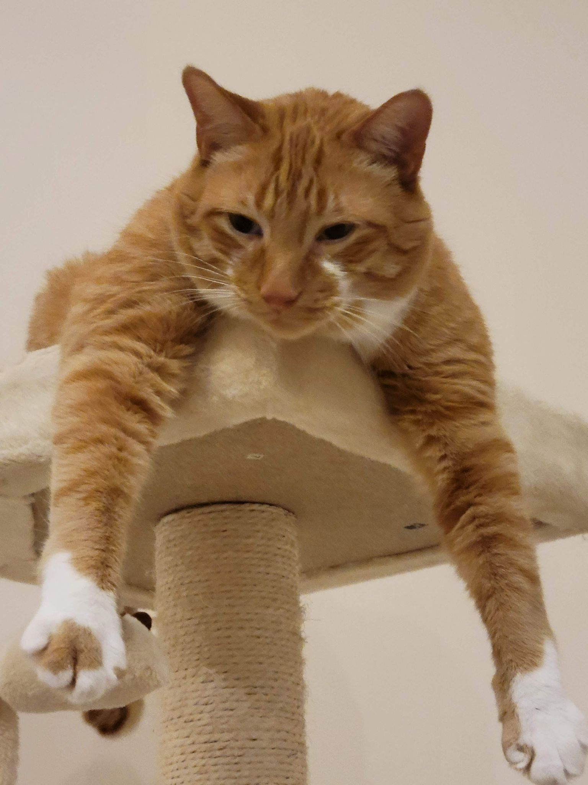
2. cheeto_cattree.jpg
3. Orange cat hanging paws off a cat tower
4. Cheeto is a cat who likes to eat a lot and play a lot. He has an obsession with his grandpa (human) and tries to get outside every single day. If he isn’t causing problems, he is usually hiding in a seven foot tall cat tree and sleeping.
5. Another name for Cheeto is Chicken, because sometimes he sits very scrunched up and ends up looking like a rotisserie chicken. He was nicknamed this by one of his friends, and now he understands it as his own name. He is about six years old and still acts like a younger cat, despite being middle-aged.

For the next four pictures you can just put the names of the files, you don't have to include the files in this drive, but you do need to add them to the proper Google Drive.

1. **Photo Gallery – (Just write Photo Gallery)**
2. cheeto_carpet.jpg
   1. Cheeto laying sideways on the carpet
3. cheeto_moon.jpg
   1. Cheeto lying in the sun in a half moon crescent shape
4. cheeto_boxes.jpg
   1. Cheeto lying on boxes with one leg hanging off.
5. cheeto_attack.jpg
   1. Cheeto attacking a hand trying to pet him.
6. **Likes – (Just write Likes)**
7. Treats
8. Exploring
9. My Dad
10. Divya Shankar

## Milktea

1. 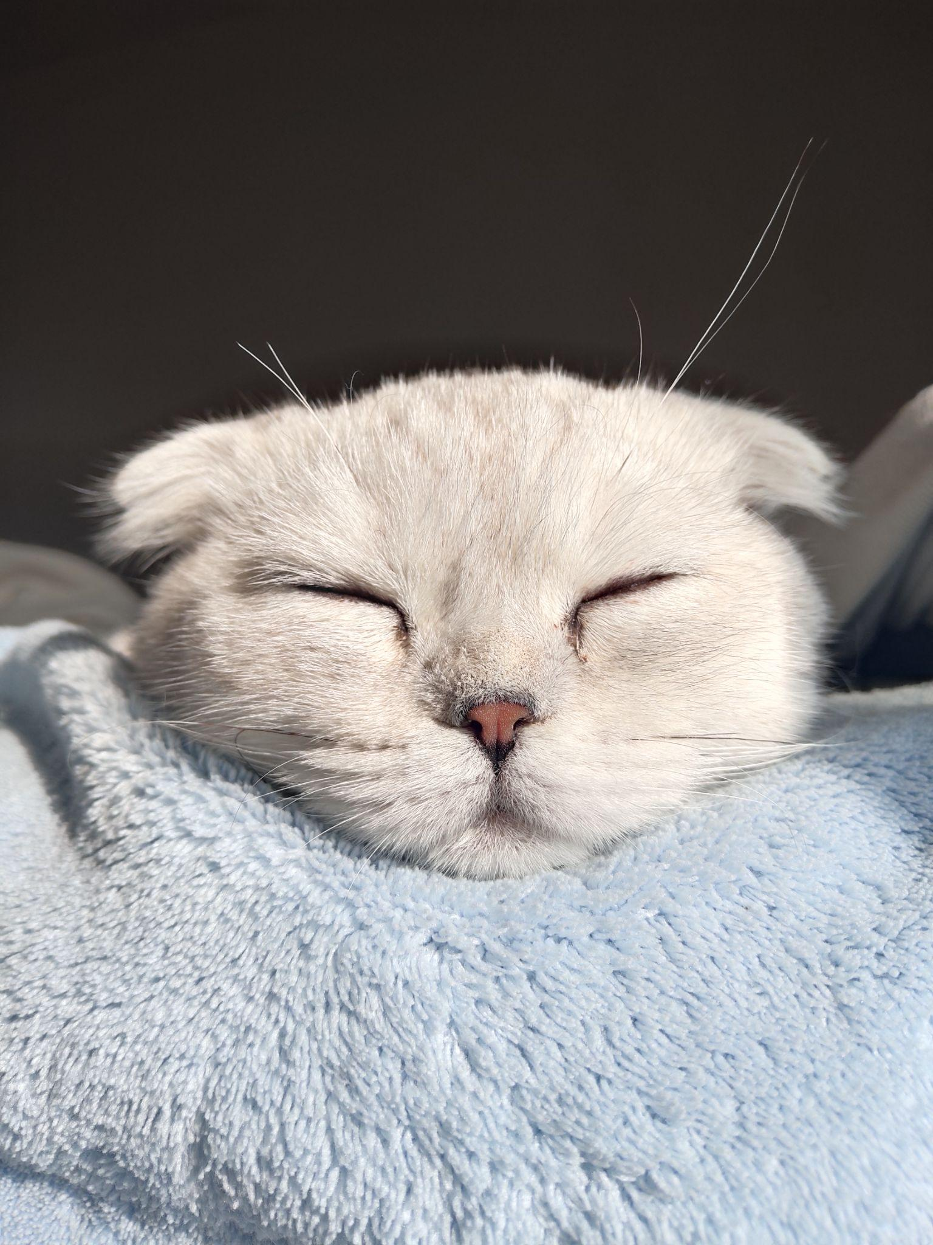
2. Filename: Main.jpg
3. Visual description: Milktea taking nap
4. Paragraph 1: Milktea is a Scottish fold with a personality of a princess. She loves her veggies and refuses to eat anything dropped on the ground. She makes it clear when she has a demand of any sort by complaining in a loud, distinguished manner. If what she says could be translated, it probably would be, “This is atrocious, the water container has been empty for the 3rd time this week. I want to see the manager.”
5. Paragraph 2: Despite her cuteness and royalty, she actually suffers from a genetic disorder intentionally brought upon by humans. I highly advise against keeping a Scottish fold because they are in constant pain when they reach around 2 years old. Cartilage accumulates around her paw joints and tail joints and it becomes painful for them to even walk. She is living evidence of human’s cruelty of breeding animals to look pretty while sacrificing the animals’ health.
6. **Photo gallery**
7. File name: Milktea_comfy.jpg
8. Visual description: Milktea enjoying a good massage
9. File name: Milktea_laptop.jpg
10. Visual description: Baby Milktea On Laptop
11. Filename: Milktea_mirror.jpeg
12. Visual description: Milktea sighing at mirror
13. File name: Milktea_catbox.jpg
14. Visual description: Milktea Catbox position

**16. Likes**

17. She loves individual corn kernels served on human hands

18. She enjoys sitting royally on suitcases to claim ownership of her humans

19. She prefers to be alone and sit on soft surfaces in her free time

20. Olive Ren

## Mochi

1. 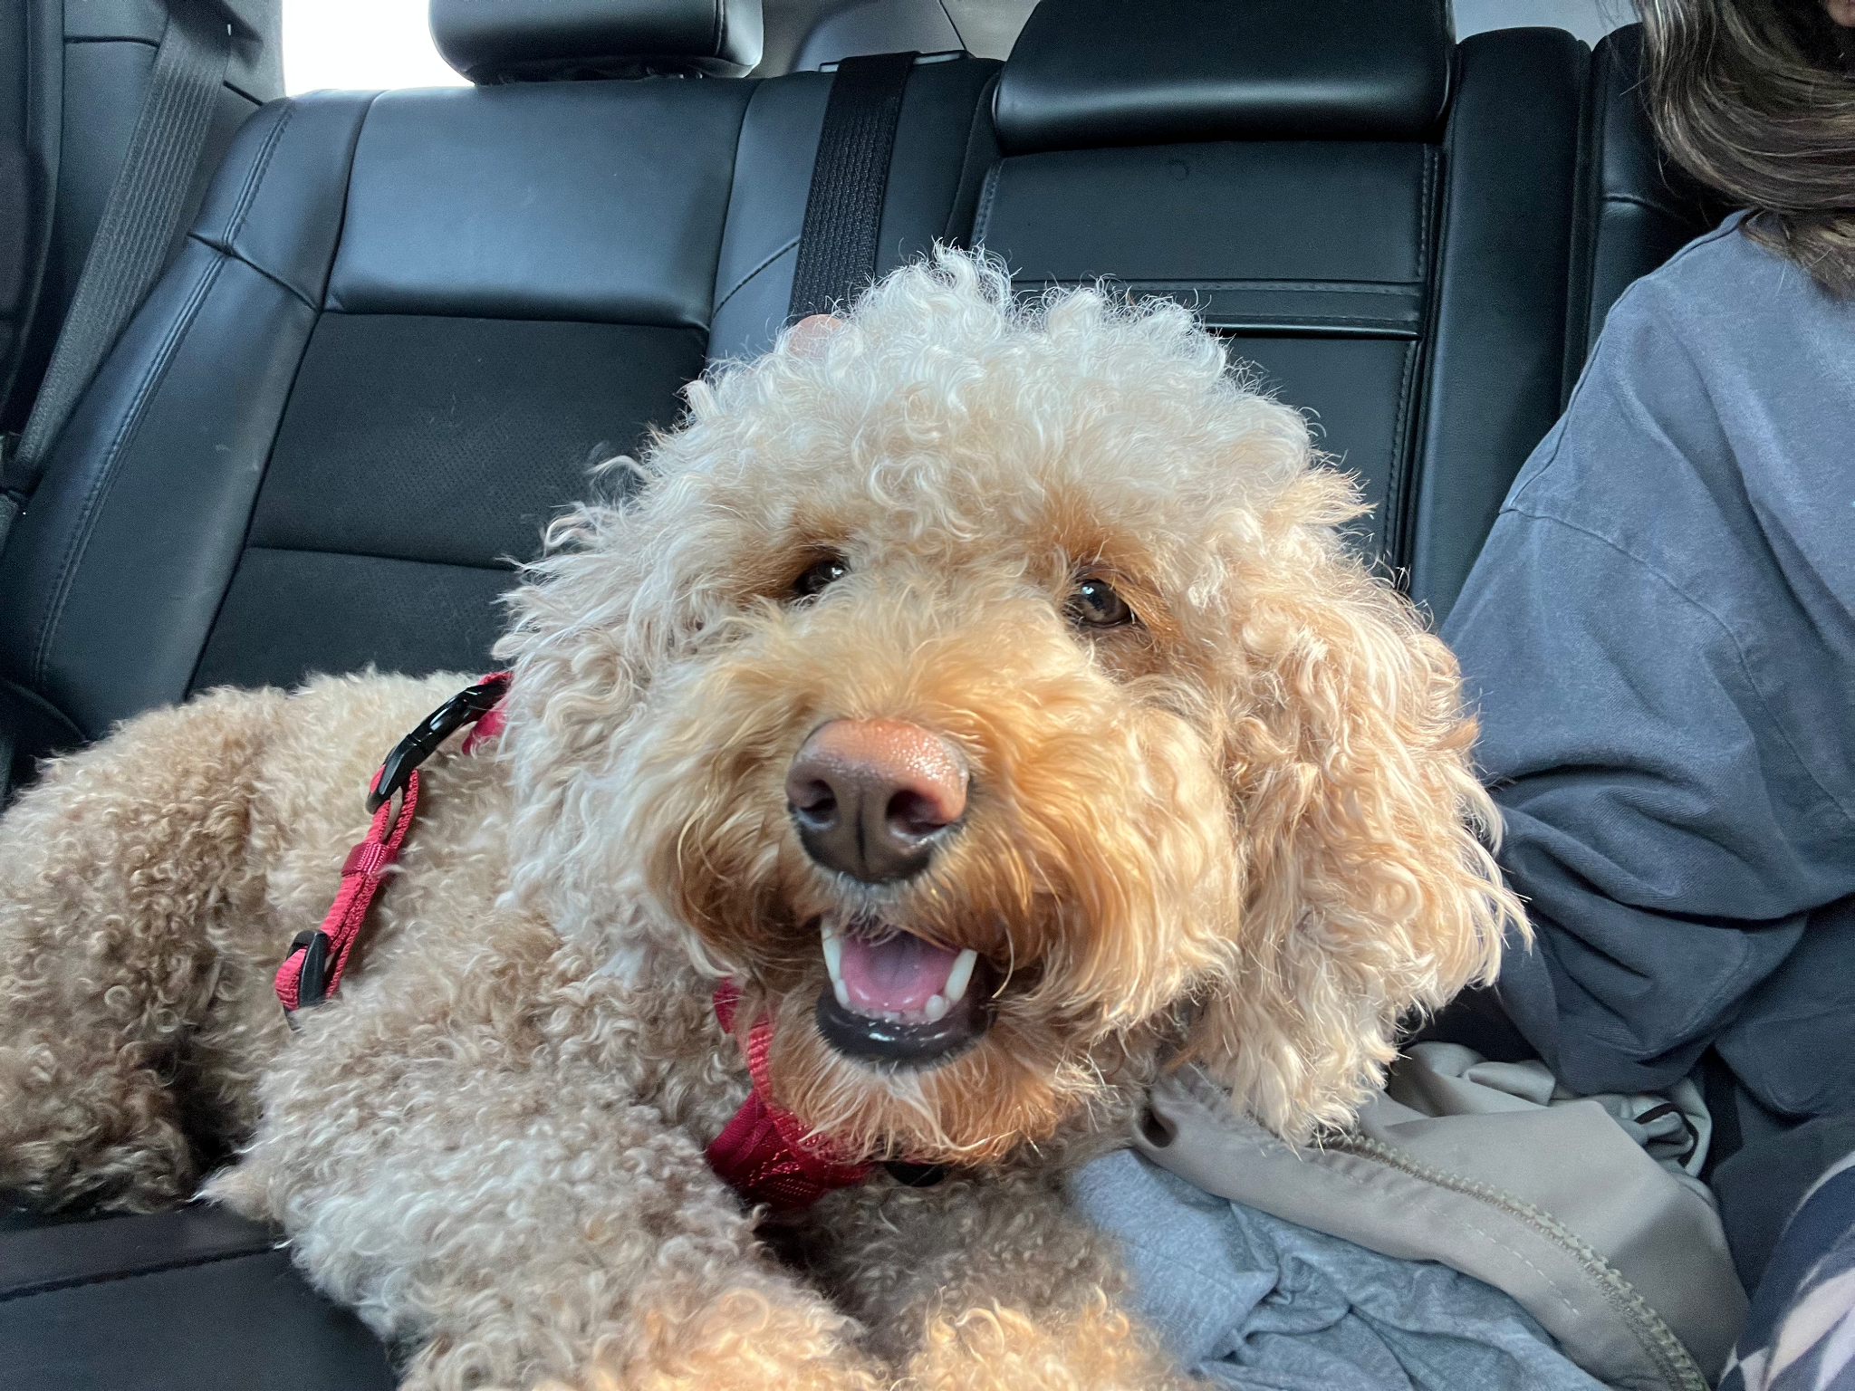
2. Mochi.jpg
3. Brown smiley dog
4. Mochi is my sister's dog, and we got her a little over two years ago. She is a true quarantine dog and therefore is scared of everyone— especially men. She hates my dad the most, and ironically loves my mom the most.
5. Currently Mochi is living in Arkansas, as my sister has gone to med school there. She enjoys the long winding pathways and nice greenery, which are very different from Baltimore which is where she used to live!
6. **Photo Gallery**
7. moch2.heic
8. Dog laying on couch with paws up
9. moch3.heic
10. Mochi sleeping with window behind
11. Moch4.heic
12. Mochi with hind legs stretched out funny
13. moch5.heic
14. Mochi looking scruffy
15. **Likes**
16. Peanut Butter
17. Laying in the sun
18. Playing fetch but not returning the ball
19. Sarasee Kiran

## Jax

1. Jax.jpg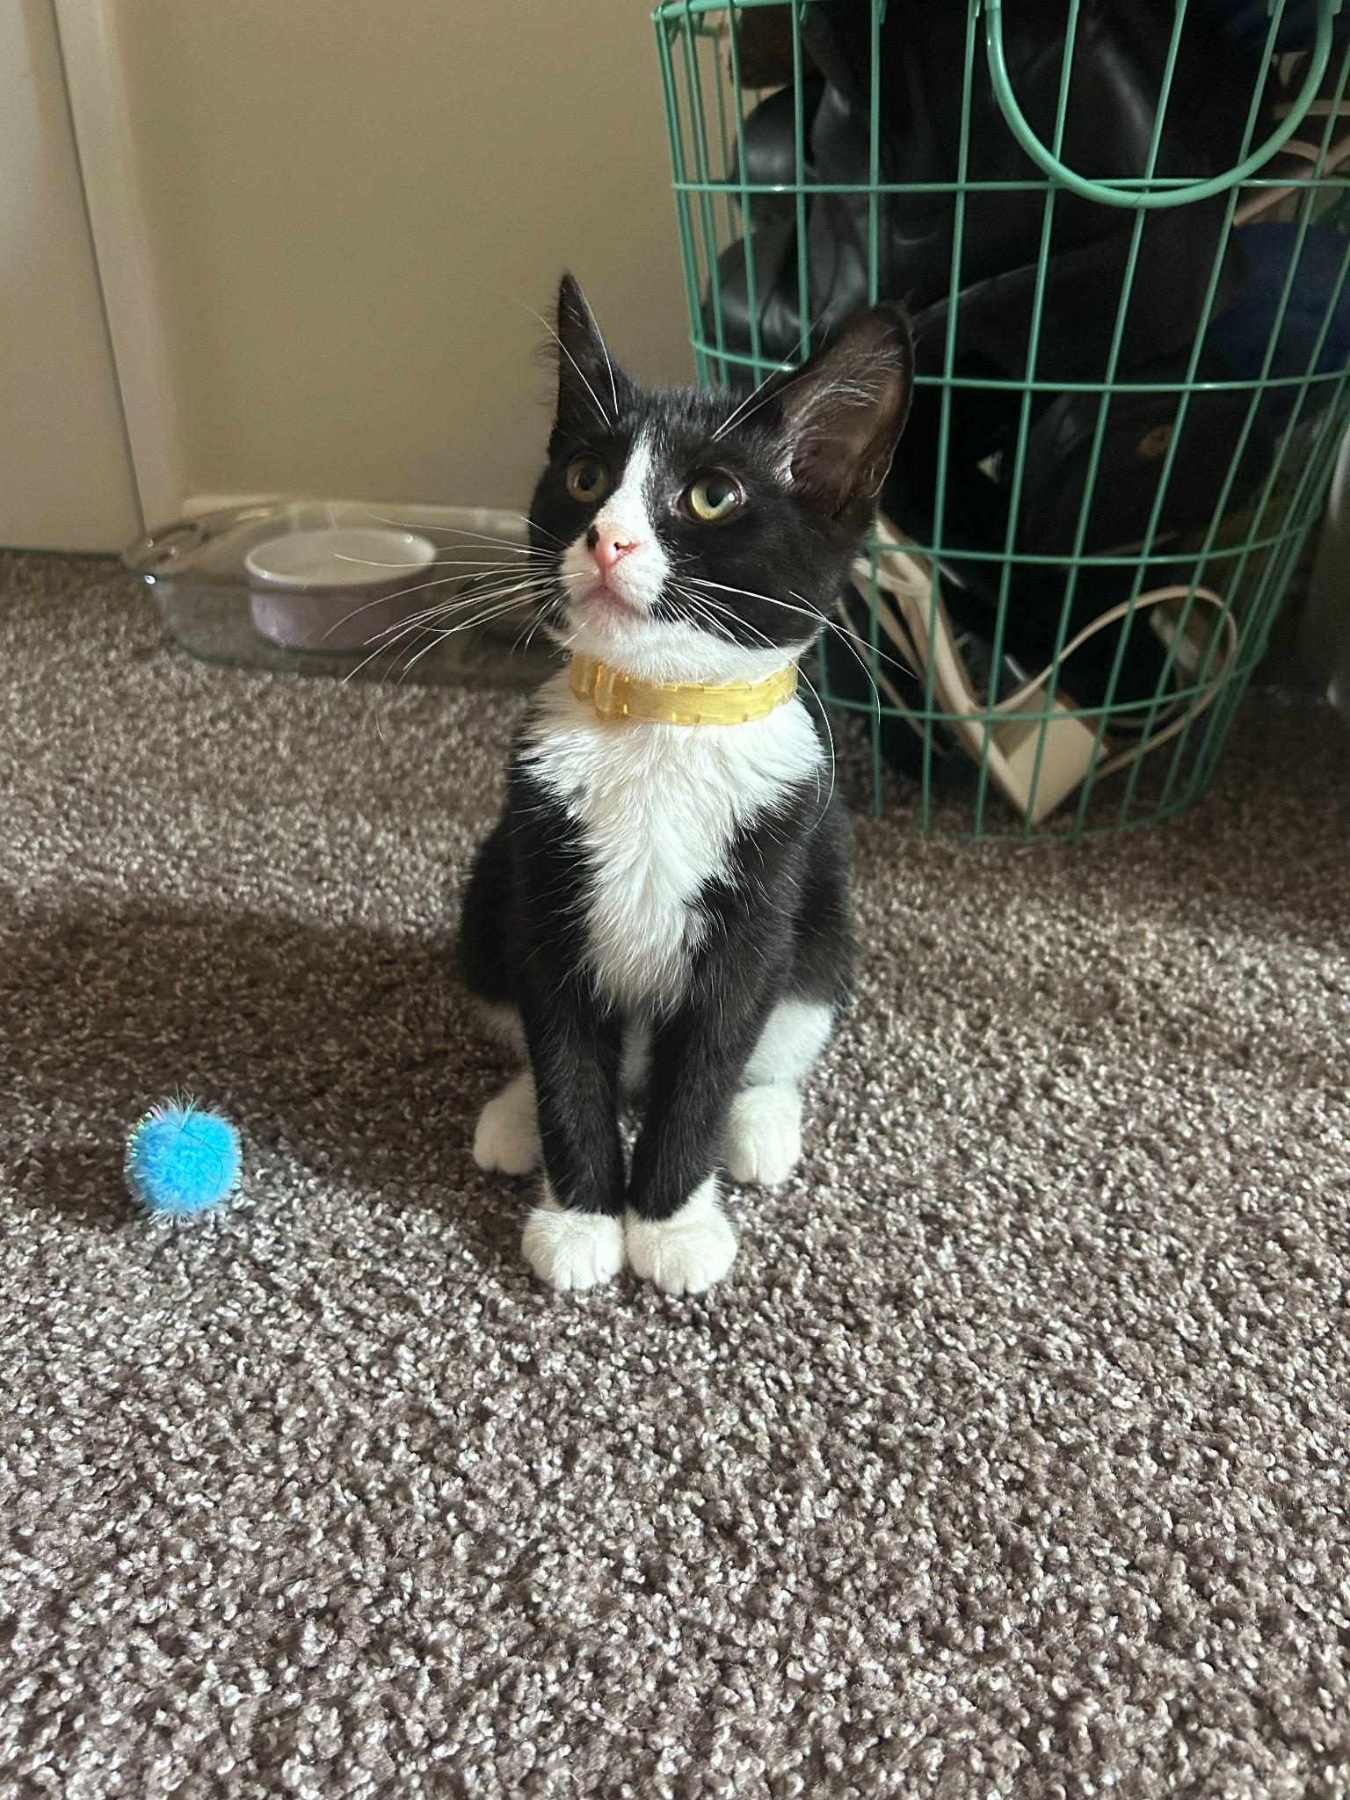
2. A black and white kitten sitting down and wearing a yellow collar.
3. Jax is a kitten, about five months old that I found this summer at a gas station while traveling to Marquette, Michigan. He was scared and malnourished, crying in the parking lot. I took him with me and after some healthy meals and a trip to the vet he is doing great!
4. My roommates and I just recently moved and Jax has been having a hard time getting used to the large house since we were previously living in a small apartment. Jax is incredibly playful and loves to run around, but when he is sleepy he is happy to be held.
5. **Photo gallery**
6. JaxandMax.jpg
7. Black and white kitten standing on the driver’s arm while on a road trip.
8. JaxHarlowLake.jpg
9. Black and white kitten on a leash standing on a rock above a lake.
10. JaxSleeping.jpg
11. Black and white kitten sleeping on a windowsill.
12. JaxDashboard.jpg
13. Black and white kitten lying on the dashboard of a car while crossing the Mackinac Bridge.
14. **Likes**
15. Toys
16. Going outside
17. Attention
18. Grace Jermstad

## 

## Ginger

1. 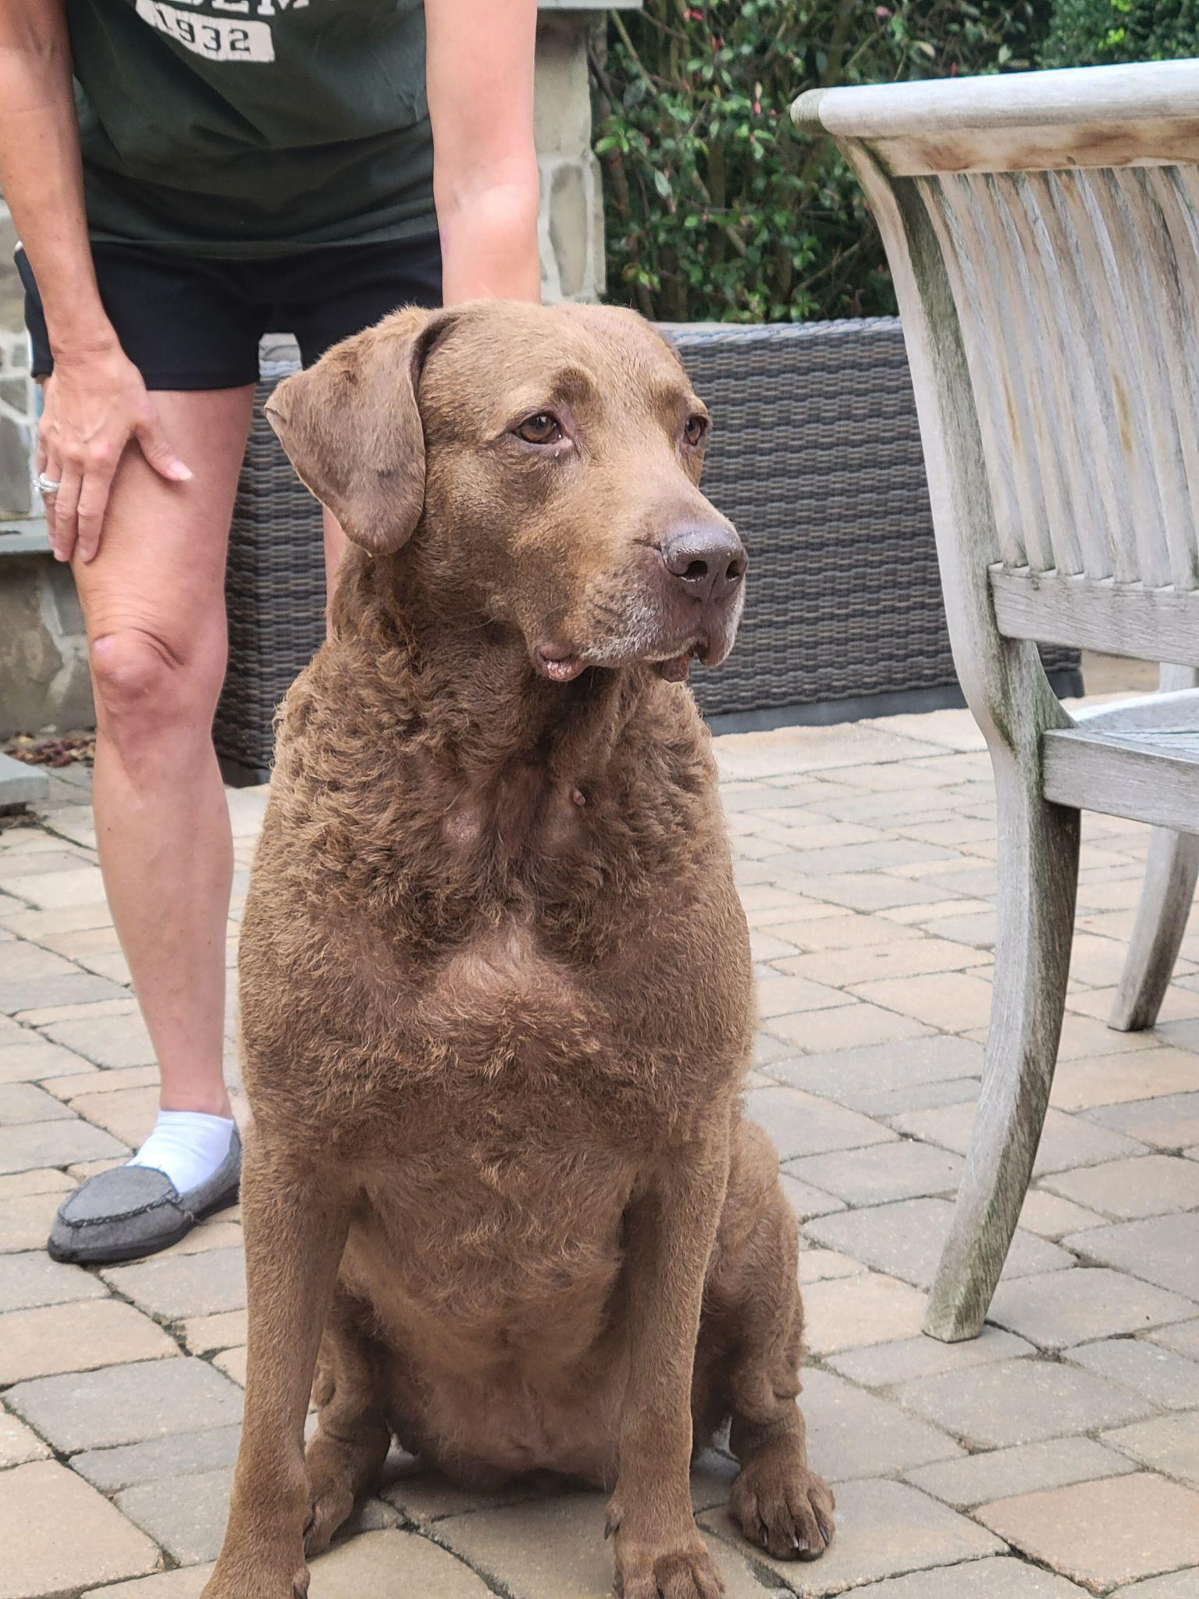
2. Ginger.jpg
3. Brown Chesapeake Bay Retriever sitting
4. Ginger is a 6 year old Chesapeake Bay Retriever. Her favorite activities are swimming in our pool and running around our yard. Occasionally she likes to chase after squirrels and groundhogs that pop up around our yard. She also likes to hog all the dog toys in the house so nobody else can have them. She enjoys antagonizing her younger brother Hank, and you can usually see them rough housing around the house.
5. When Ginger isn’t playing she enjoys sitting in her bed unbothered. She will go onto her bed, and then will turn on her selective hearing. That is when you know that she will side-eye you for anything you are doing.
6. **Photo Gallery – (Just write Photo Gallery)**
7. Ginger_Paw.jpg
8. Brown Chesapeake Bay Retriever pawing owner
9. Ginger_Puppy.jpg
10. Younger version of brown chesapeake bay retriever
11. Ginger_ToungeOut.jpg
12. 2 year old brown chesapeake bay retriever with tongue out
13. Ginger_gazing.jpg
14. Brown Chesapeake Bay Retriever laying down on white bed
15. **Likes – (Just write Likes)**
16. Pools
17. Toys
18. Her Brother Hank
19. Joseph Marino

## Leo

1. 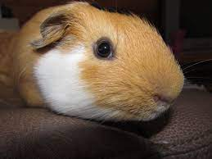
2. Leo_primary_photo.jpg
3. Guinea pig doing his best to smile for the camera
4. Guinea pigs are a naturally energetic animal, who spend up to 20 hours a day awake. Despite being awake for long periods of time, they naturally hide in their habitats, and can be difficult to see in their inclosures. Guinea pigs naturally are social creatures that enjoy socializing with other guinea pigs, in the wild they form packs of five to ten.
5. Leo is a half-lazy, half-lively guinea pig that either likes to run around on the floor, doing tiny hops, or likes to lay down in the cage for hours at a time nibbling at hay. His favorite hobby is eating, and he can tell whenever someone is about to give good to him by waiting at the end of the cardboard box patio he has attached to his cage.
6. **Photo gallery**
7. Leo_greens.jpg
8. Leo enjoying leafy greens.
9. Leo_run.jpg
10. Leo running across his cage as fast as he can.
11. Leo_smile.jpg
12. Leo smiling for the camera.
13. Leo_escape.jpg
14. Leo socializing with other guinea pigs as they plan their escape.
15. **Likes**
16. Lettuce
17. Tiny Hops
18. Nap Time
19. Justin Fischer & Alexei Chen
20. Chief
21. 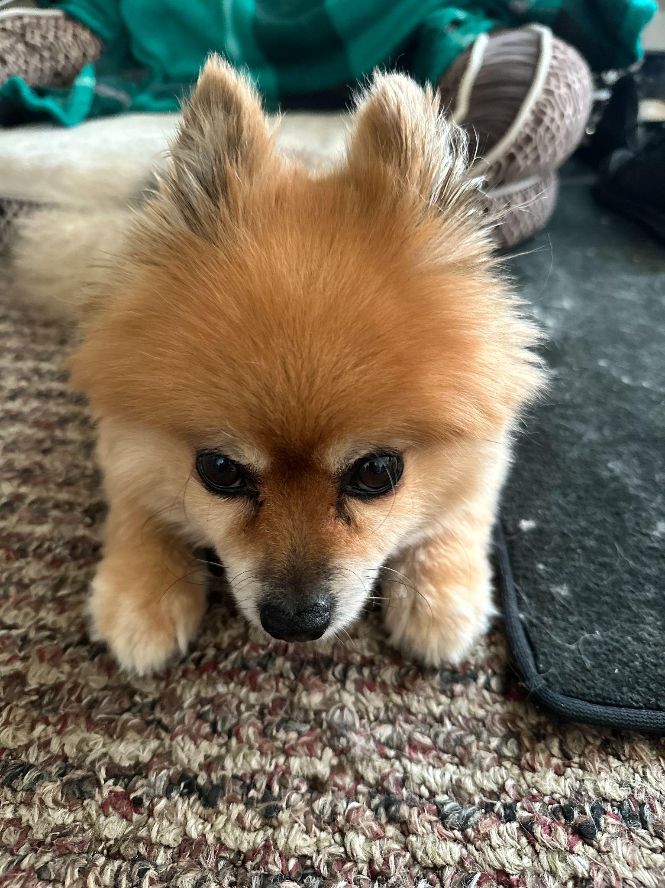
22. chief.jpeg
23. Pomeranian looking at camera with head bowed
24. Chief is a 9 year old pomeranian who loves to sleep as much as he can. He naps anywhere, ranging from someone's bed to the grass outside. He enjoys walking outside, but keep watch of him, otherwise he will try to consume geese poop.
25. He does not like any toys anymore as when he was younger, he watched a bigger toy shred his favorite one to pieces. He used to know how to roll over, but now replaced that memory with a spin as it is much easier.
26. **Photo Gallery**
27. chief_sleeping.jpg
28. Caramel pomeranian sleeping on his bed
29. chief_eating.jpg
30. Caramel pomeranian reaching for a slice of chicken
31. Chief_exposed.jpg
32. Caramel pomeranian resting with stomach exposed
33. Chief_bread.jpg
34. Caramel pomeranian with head poking through piece of bread
35. **Likes**
36. Sleeping
37. Deli Chicken
38. Pets behind the ear
39. NaveenJohn Premkumar

## Riley

1. 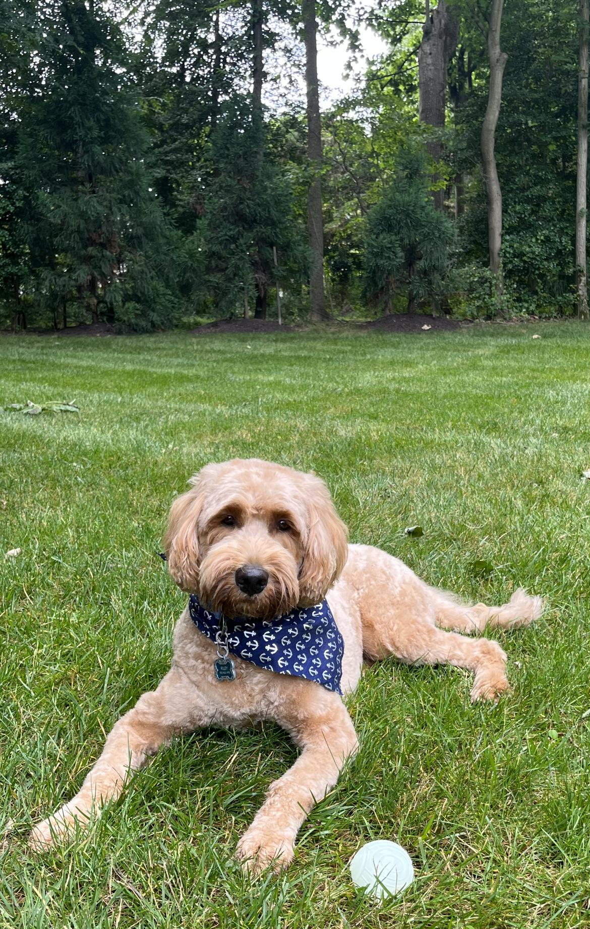
2. Riley_primary.jpg
3. Apricot goldendoodle wearing blue bandana lying next to ball
4. Riley is a 2yr old goldendoodle. He is very active and loves attention. Riley can be pretty mischievous; as such, his favorite activity is begging for (or stealing) food, however getting cuddled on a cool floor comes as a close second. In addition, Riley loves to walk in his local park or hang out with his best friend Cosmo.
5. Riley would NOT survive in the wild. He is very stubborn, jealous, and pampered. He’s currently in his “terrible twos,” and must get everything his way. That said, Riley is loved by his family as a perfect, funny, and loyal dog.
6. **Photo Gallery**
7. riley_sleeping.jpg
8. Goldendoodle peacefully resting on their dog bed
9. riley_park.jpg
10. Happy goldendoodle chilling by the Potomac River
11. riley_friend.jpg
12. Goldendoodle and traditional doodle playing together with a stick
13. riley_texting.jpg
14. Silly dog texting on an iPad
15. **Likes**
16. Sneaking onto the couch
17. Being grumpy after naps
18. Peering onto kitchen countertops
19. Adam Cole

## Oreo

1. 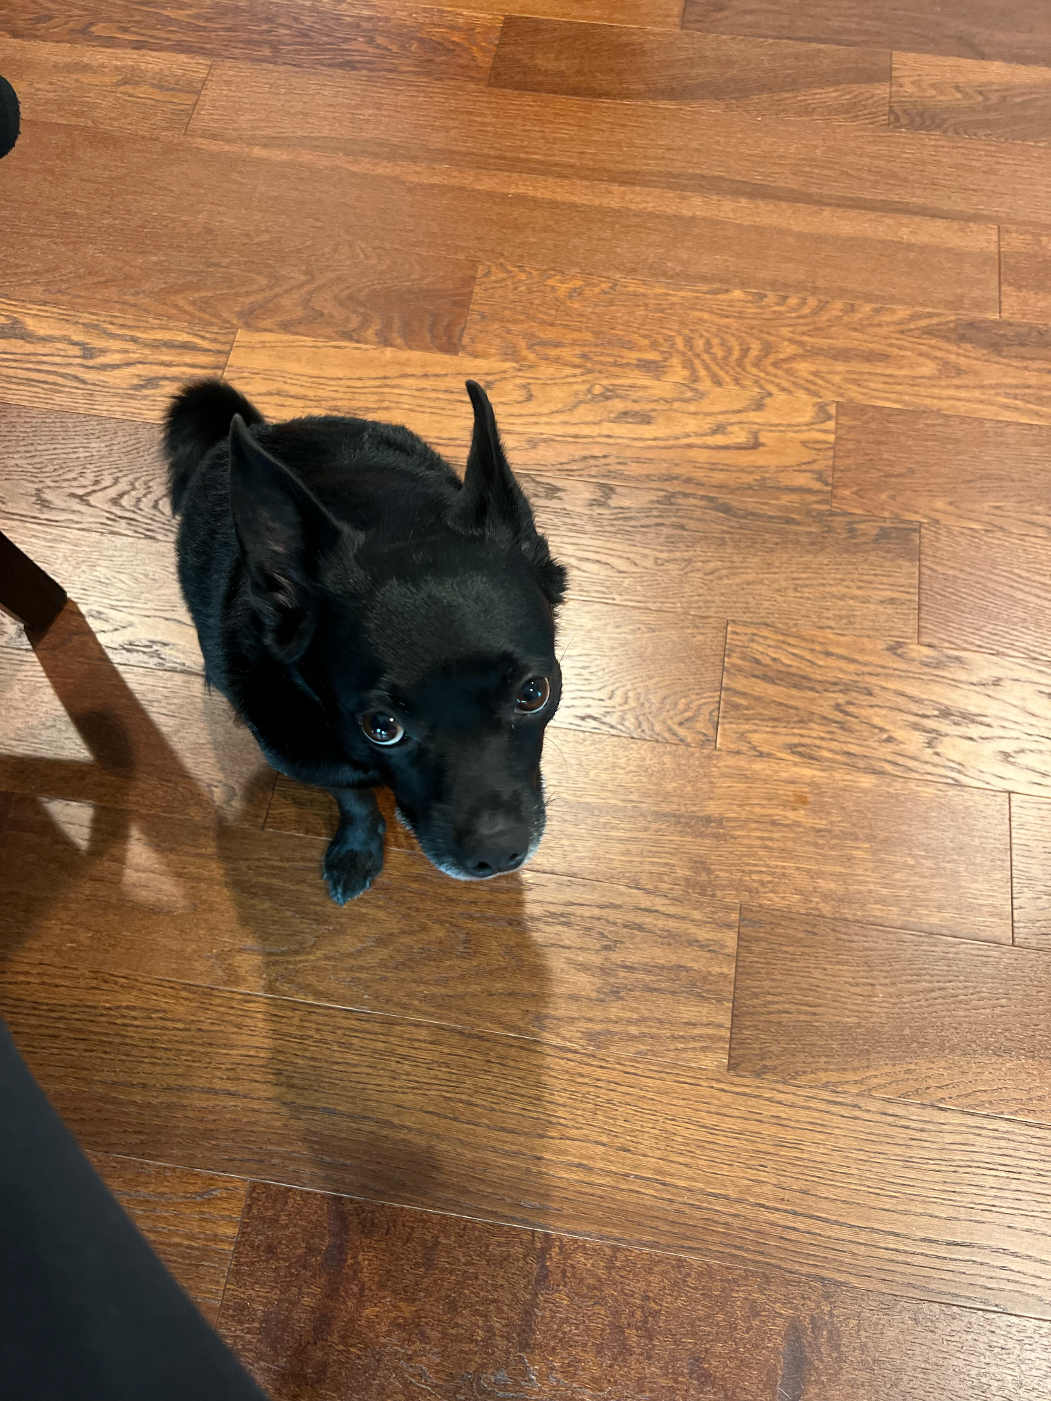
2. oreo_sitting.jpg
3. Black pug terrier
4. Oreo is a 20 pound pug terrier who is 6 years old. He loves following people around and always wants attention from anyone. He will play with any dog toys, especially the ones that you take from him. He likes going out on walks anytime of the day except when it is thunder storming, he will be running around the house trying to find a place to hide.
5. After every walk, Oreo will always get the zoomies, or he will want to play fetch. He has a set schedule everyday where he likes to eat early morning around 9am and at night at 7pm. Oreo is a very high maintenance dog who needs a lot of attention but will give you all the love and kisses.
6. **Photo Gallery**
7. oreo_laying.jpg
8. Oreo laying down staring at the camera
9. oreo_christmas.jpg
10. Oreo wearing a christmas tree headband
11. oreo_snow.jpg
12. Oreo buried in snow while wearing a winter dog jacket
13. oreo_candycane.jpg
14. Oreo sitting next to a pumpkin while wearing a candy cane headband
15. **Likes – (Just write Likes)**
16. Fetch
17. Chicken
18. Walks
19. Jasmine

## **Cooky**

1. 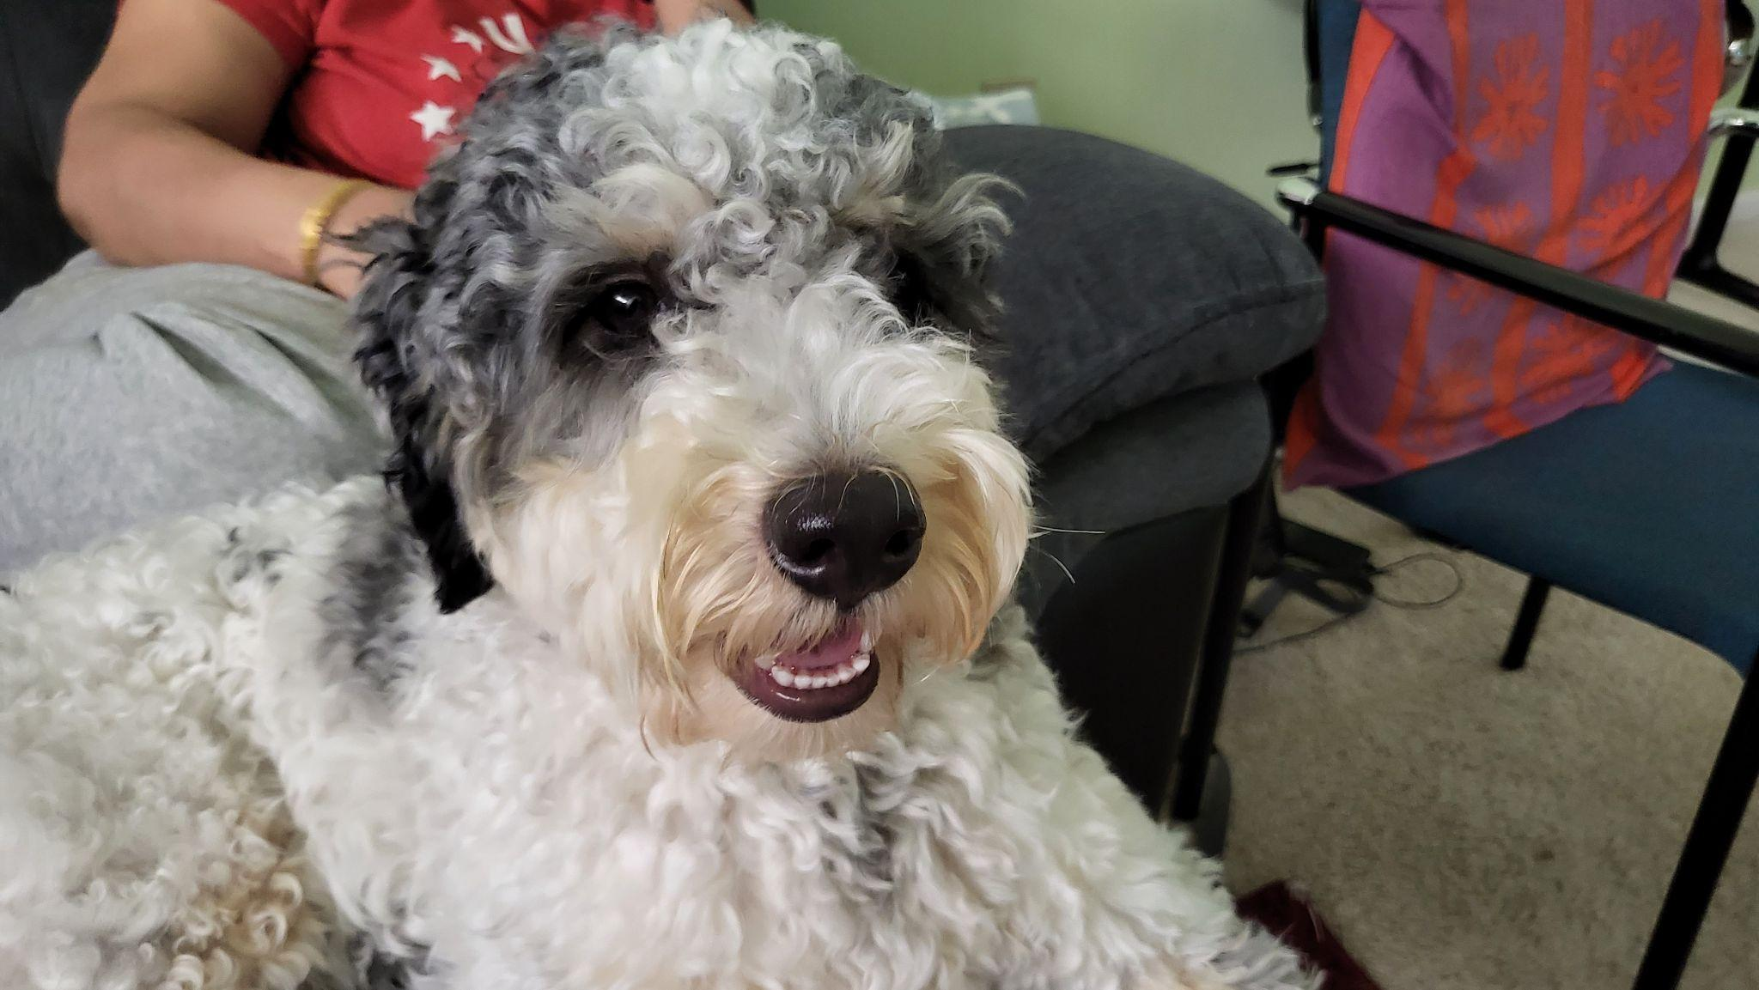
2. cookysmiley.jpg
3. White and gray Bernedoodle sitting on a couch and smiling.
4. Cooky is an 11 month old Bernedoodle. He likes to play, run around, go on walks, eat snacks and treats (not his own dog food), get pets and belly rubs, and cuddle. You can usually find him playing with his toys in the living room, chilling in the office room with my dad, or cooling off in the garage.
5. He’s still a baby, but he can get super hyper. Whenever someone rings the doorbell, Cooky gets really excited, barking and dashing towards the front door. He also jumps really high when he’s hyper and wags his tail like crazy. Overall, though, he likes to chill and cuddle just as much as he likes to play.
6. **Photo Gallery**
7. cookytreat.jpg
8. Cooky eating one of his favorite treats while lying on the ground
9. cookytired.jpg
10. Cooky tired laying on the ground
11. cookycone.jpg
12. Cooky with long hair sitting with a dog cone on his head
13. cookyzoom.jpg
14. Zoomed in Cooky, but while I was taking the picture he moved so it’s blurry
15. **Likes**
16. Dog cookies
17. Pets and belly rubs
18. Running around the house
19. Saicharan Vemuri

## Leo

1. 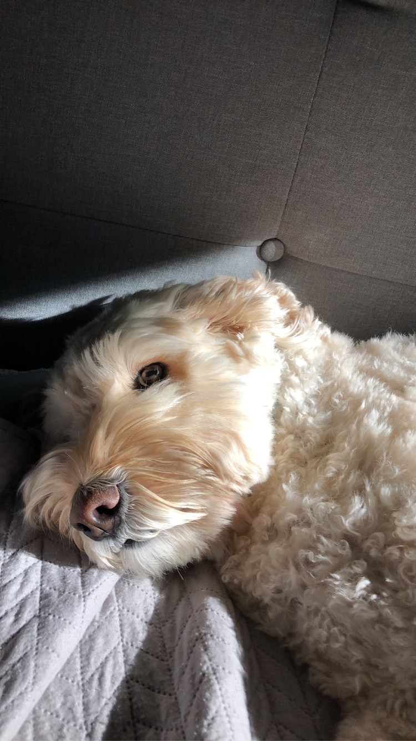
2. labradoodle_leo.JPG
3. Tan labradoodle
4. Leo is a very hyper labradoodle who enjoys running around and meeting new people. Leo recently turned six back in July, and received two toys for his birthday which he has already destroyed. Leo also enjoys laying around the house, his favorite spots being my parents bedroom and the living room couch.
5. Leo is a big fan of when the mailman comes because that means he will get a treat. At bedtime, Leo waits for both of my parents to get into bed before he goes to bed. He thinks he needs to guard them while they are both still awake.

For the next four pictures you can just put the names of the files, you don't have to include the files in this drive, but you do need to add them to the proper Google Drive.

1. **Photo Gallery**
2. leo_staring.JPG
3. Me staring at Leo
4. leo_anna.JPG
5. Leo with my sister Anna
6. happy_leo.JPG
7. Leo staring at me because I have food
8. leo_family.JPG
9. Leo with my family
10. **Likes**
11. Naps
12. Food
13. Going on walks
14. John Sauer

## River

1. 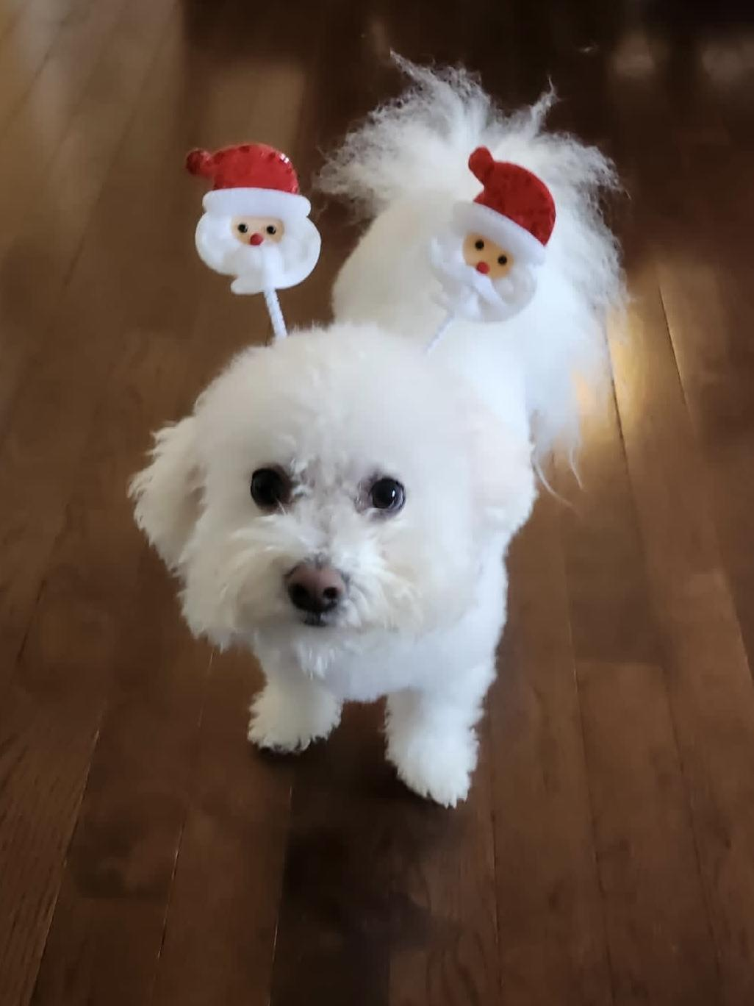
2. river.jpg
3. Fluffy bichon frise wearing santa headband
4. River is a 7 year old bichon frise. Though he is aging, he is extremely active and loves to play. He likes to throw things. He will throw his ball down the stairs and play fetch with himself if you don’t give him attention. He will also throw his food and water bowl to let us know he wants more.
5. River is obsessed with my mom. My mom is the one who mostly walks him and gives him treats. Anywhere my mom goes, River follows. If she's gone for 2 minutes, he will frantically search the house for her. Although he likes being with people, he hates being cuddled or held.
6. **Photo Gallery**
7. river_boss.jpg
8. Bichon frise on his bed, showing who is boss
9. river_model.jpg
10. Bichon frise posing for camera after getting a haircut
11. river_yawn.jpg
12. Bichon frise tired and yawning
13. river_suit.jpg
14. Bichon frise in a suit, ready for prom
15. **Likes**
16. Attention
17. Treats
18. Rolling ball down the stairs
19. Erin Lee

## Dollar

1. 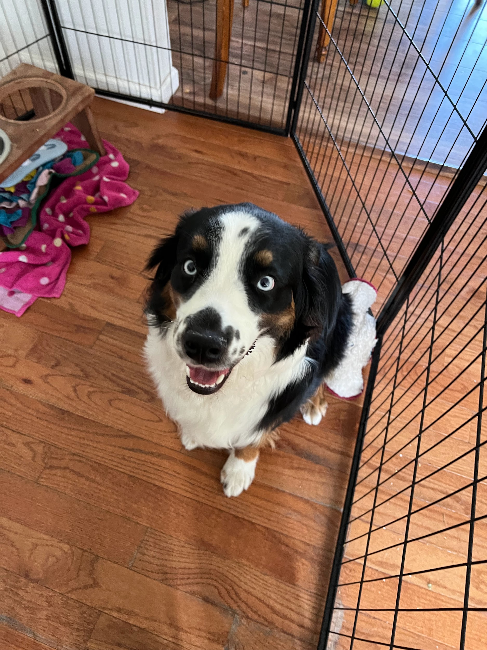
2. Dollar1.HEIC
3. Black, white and brown australian shepherd in a playpen looking up with a food bowl and towels on the side.
4. Dollar is a 1 and a half year old Australian shepherd. His favorite games are tug of war and fetch. Sometimes, when he goes out for walks, he will pick up a stick to get his owners to play fetch with him. At night, he likes to cuddle with his owners. He would snuggle up and put his nose on their arm to let them know that he wants pets.
5. Dollar has a gourmet taste for food. He hates eating kibble and will only eat premium chicken bits with eggs. His favorite snacks are bell peppers, beef bits, and peanut butter. Dollar is incredibly smart and will only do tricks when you present him with snacks.

For the next four pictures you can just put the names of the files, you don't have to include the files in this drive, but you do need to add them to the proper Google Drive.

1. **Photo Gallery**
2. Dollar2.HEIC
3. Black, white, and brown australian shepherd in a photograph with a certificate in front of him.
4. Dollar3.HEIC
5. Black, white, and brown australian shepherd laying down on his back, exposing his underside.
6. Dollar4.HEIC
7. Black, white, and brown australian shepherd laying on the grass with a leash on
8. Dollar5.PNG
9. Black, white, and brown australian shepherd with a shirt tied around his head
10. **Likes**
11. Bacon Bits
12. Taking walks in the park
13. Jumping on the sofa
14. Jing Li

## Carlos

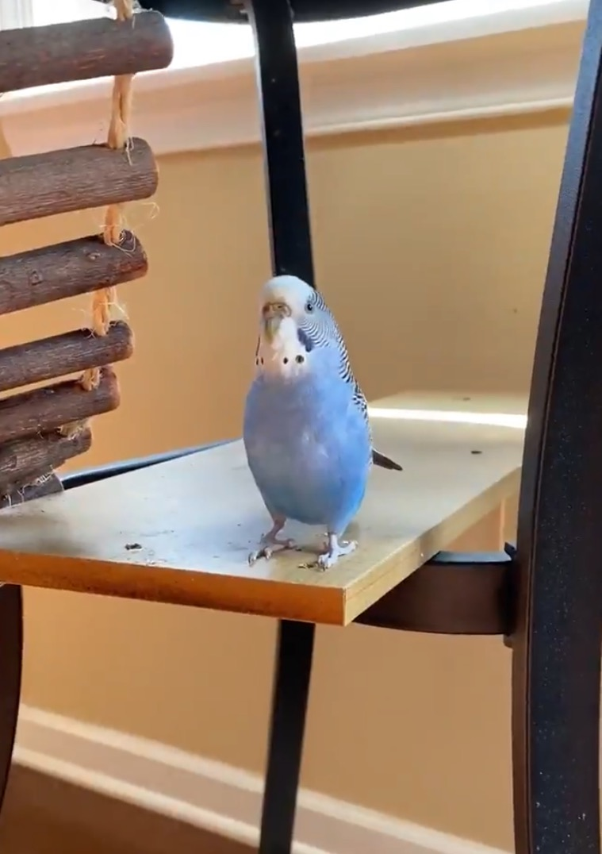

1. carlos.jpg
2. Blue parakeet crouching about to fly
3. Carlos is a blue parakeet/budgerigar that my older sister adopted from her friend in high school. Carlos is 9 years old and loves flying around the kitchen and standing on chandeliers. She has very loud chirps and loves to chatter when people play instruments. Although she can be aggressive at times and is very unfriendly towards strangers, she has a very soft bite.
4. Carlos has a sister named Einstein. We did not discover the genders of our pet birds until years after we named them. At night, Carlos always sleeps on her favorite yellow swing and will wake up in the same spot every morning in the upstairs of her cage ready to come out and play.
5. **Photo Gallery**
6. carlos_einstein.jpg
7. Blue parakeet standing with green parakeet
8. carlos_cynthia.jpg
9. Blue parakeet standing on girl’s shoulder
10. carlos_preening.jpg
11. Blue parakeet preening feathers
12. carlos_tall.jpg
13. Blue parakeet standing tall
14. **Likes**
15. Spinach
16. Flying around
17. Taking baths
18. Julia Zhang

## Rocky

1. 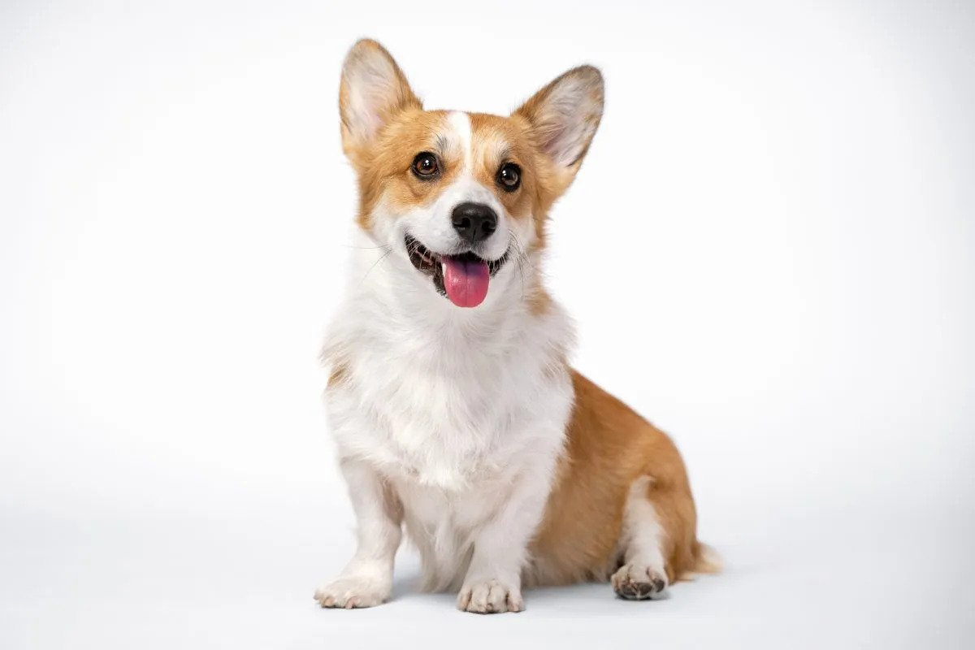
2. corgi.jpg
3. Smiling corgi against plain white background
4. Rocky is a 5 year old corgi. He prefers going for a jog than lounging around the house. He’s full of energy and loves to show his affection by snuggling up next to me while watching some Netflix.
5. One thing I definitely overlooked when we got Rocky was the amount this little guy could shed! I spent an hour vacuuming our carpet floors just the day after he entered our homes! However, I would vacuum up and down the walls of our home for him, my life-long pal and good boy.

For the next four pictures you can just put the names of the files, you don't have to include the files in this drive, but you do need to add them to the proper Google Drive.

1. **Photo Gallery**
2. corgi1.jpg
3. Corgi in autumn
4. corgi2.jpg
5. Corgi on a staircase
6. corgi3.jpg
7. Corgi leaping across the grass
8. Corgi4.jpg
9. Corgi leaping across the grass - profile
10. **Likes – (Just write Likes)**
11. Peanut Butter
12. Bouncy Balls
13. Tummy Rubs
14. Nicholas Alexander

## Biscuit

1. 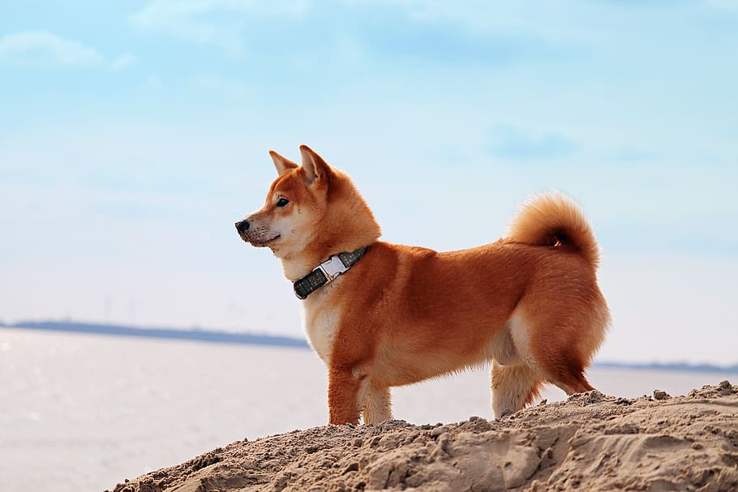
2. Biscuit1.jpeg
3. Shiba inu sitting in front of pond with stones in the background
4. Biscuit is a 2 year old shiba inu dog. Shiba inus are energetic and playful dogs. Biscuit enjoys running outside in circles and then laying down in the grass in the sun for hours. He also likes going for occasional swims.
5. As energetic as Biscuit is, he also likes to relax. He loves to sleep in his dog bed and watch Netflix with his owners. His favorite treat is apples.
6. **Photo gallery**
7. biscuit2.jpeg
8. Biscuit standing in the sunlight
9. biscuit3.jpeg
10. Biscuit smiling for the camera
11. biscuit4.jpeg
12. Biscuit standing near the road
13. biscuit5.jpeg
14. Biscuit sleeping
15. **Likes**
16. Going for walks
17. Swimming
18. Apples
19. Allison Lee

## Jojo

1. 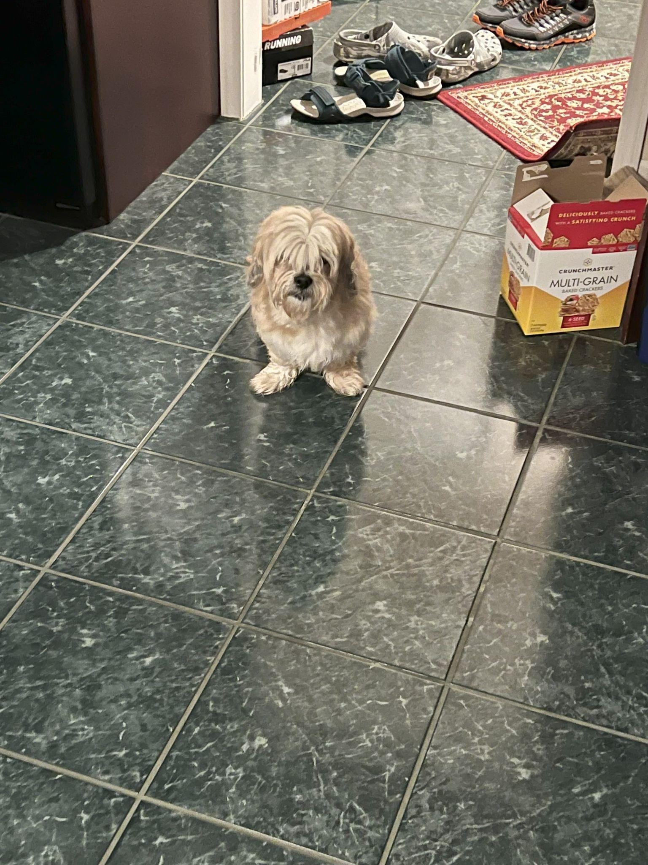
2. jojo.JPG
3. White/light brown small Lhasa-Apso
4. Jojo is a 14 year old dog that has grown up with me. He’s a Lhasa-Apso which is a breed from Tibet that’s known to be a watchdog. Funny enough, Jojo acts exactly like a watchdog. He likes to spend his days sitting next to a window looking and barking at people passing by. He is only a watchdog though, as he gets scared very easily.
5. His favorite thing in life is food and his favorite foods are sweet potatoes and naan. He loves walks as well, however he will not go outside if it’s raining or if there’s a lot of snow on the ground. He’s taken some old blankets and pillows we had to make his own bed. He’s also trilingual, able to understand English, Hindi, and Japanese.
6. **Photo Gallery**
7. jojo_standing.JPG
8. Small light brownish dog standing
9. jojo_sleeping_car.JPG
10. Small light brownish dog sleeping in a car
11. jojo_car_window.JPG
12. Small light brownish dog putting head outside moving car
13. jojo_door.JPG
14. Small light brown dog laying next to stuffed bear
15. **Likes**
16. Being carried like a baby
17. Walks
18. Sleeping
19. Roshan Kawaguchi Sadhu
20. Mini
21. 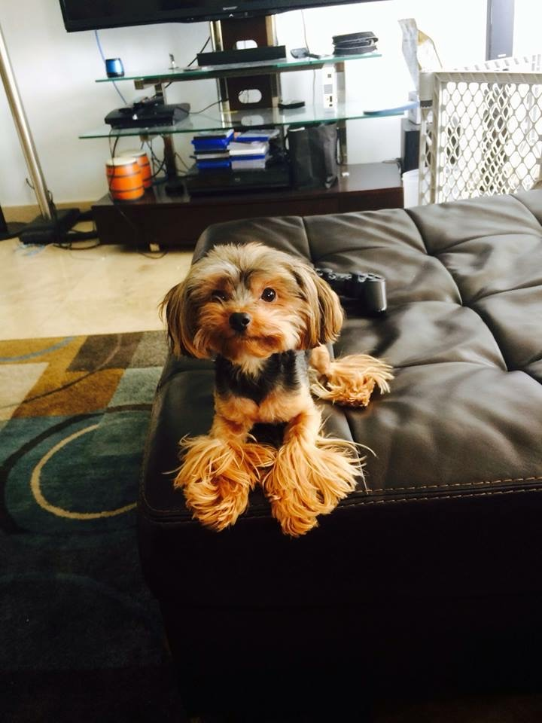
22. miniPosing.jpg
23. Mini is a 10 year old yorkshire terrier who’s grown up along with me. She enjoys playing and taking baths and is the sweetest dog you could ask for. My mom brought her from a shelter in Ecuador when she was just a couple of months old and even though it was over ten years ago, I remember that day like it was yesterday.
24. Mini’s quite small, even smaller than the average yorki so she’s quite sensitive physically speaking. However, she still tries to protect our home when she hears a stranger at the door despite her size. Mini loves her family and has a big heart!
25. **Photo Gallery**
26. mini.jpg
27. Mini riding in a car
28. mini1.jpg
29. Mini being spoiled in a car
30. mini2.jpg
31. Mini waking up from a nap
32. mini3.jpg
33. Mini waking up from a nap again
34. **Likes**
35. Squeaky Toys
36. Baths
37. Belly Rubs
38. Alessandro Lorenzo

## Subin

1. 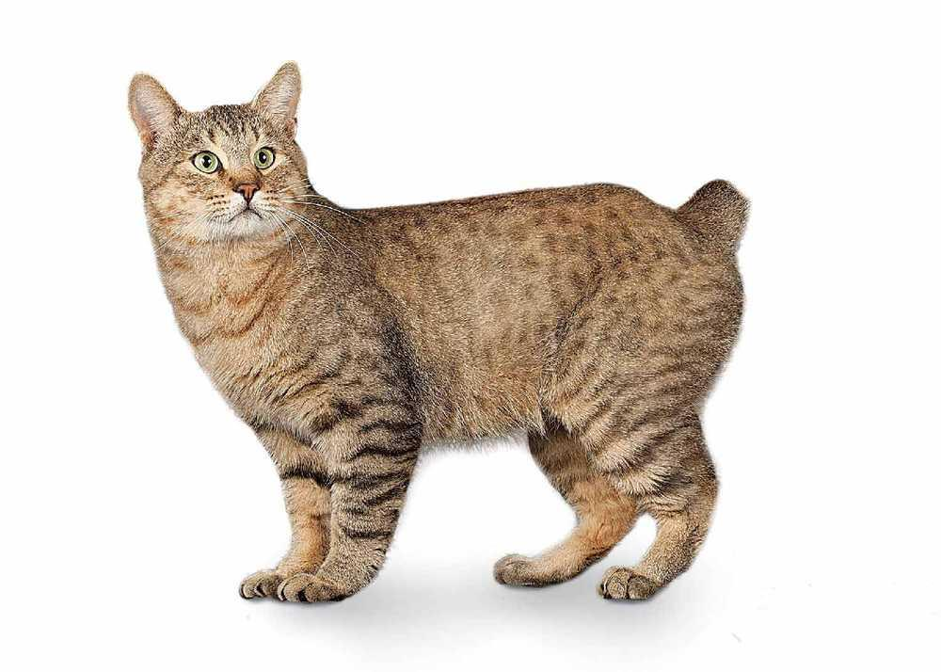
2. BobTailCat1.jpeg
3. Yellow/Brown with small black stripes with a cute stubby tail
4. One of my earliest memories was spending time with a newly born Subin, So in a way, we grew up together. Therefore, from going to the store at the end of the road to eating together, we did everything together.
5. Subin was somehow not bothered by vaccum cleaners. Even though the loudness of it was able to scare any animals away, Subin enjoyed the chaos of it, opting to even sit on the handle as we vaccum.
6. **Photo Gallery**
7. BobTailCat2.jpeg
8. Small young subin with blue background facing towards the camera
9. BobTailCat3.jpeg
10. Small young subin with blue background looking bottom left
11. BobTailCat4.jpeg
12. Older subin with a greenish blue background ready to pounce
13. BobTailCat5.jpeg
14. Very old and mature subin with a brownish yellow background looking at the camera
15. **Likes**
16. Hitting people’s faces
17. Sleeping under the sun
18. Laying on a keybaord
19. Ramsey (Nyang Lin Phyo)

## Dukey

1. 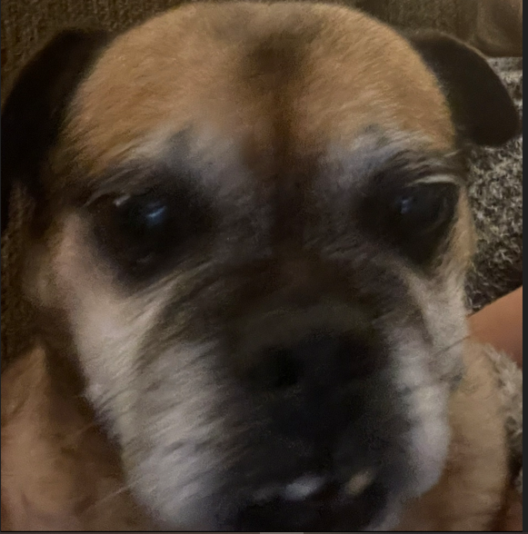
2. dukey.jpg
3. Brown, Pug, Jack Russell mix staring at the camera
4. Dukey is a 12 year old Pug, Jack Russell mix and lives with me and my family in Ireland. He is a very small dog, but acts much bigger than his size. He may look like an old man but still has the personality of a new born puppy.
5. Dukey’s favorite treat are rich tea cookies, as well as anything that falls off of the table at meal time. The rest of the family may call him the family dog, but both him and I know he’s really my dog, and one of my best friends.
6. Photo Gallery
7. dukeysleep.jpg
8. Dog asleep under a gray blanket
9. dukeysuprise.jpg
10. Dog on a blanket looking behind himself
11. dukeyincar.jpg
12. Dog sitting on a white blanket in the back of a car
13. christmasdukey.jpg
14. Dog looking at camera in front of two small christmas trees
15. Likes
16. Cookies
17. Blankets
18. Walks (but not long ones)
19. Luke Morris

## Hazel

1. 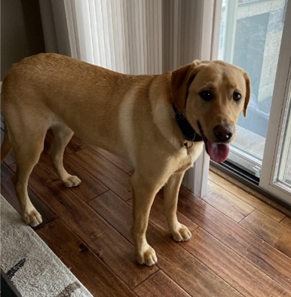
2. Hazel.jpg
3. Yellow Labrador retriever standing in front of a glass door.
4. Hazel is a year-old yellow Labrador retriever that enjoys long walks and playing catch (in or out of the water). She has a lot of energy, so she gets restless if she does not have enough exercise. Hazel loves meeting new people and seeing old friends. She likes to jump on people, but she is friendly and does not mean any harm.
5. Hazel will eat anything and everything. Like most Labrador retrievers, she loves food and will eat things that are not actually edible. Some of the things that Hazel has chewed on include hand towels, blankets, Apple Airpods, and Halloween decorations. She also loves to eat human food such as lettuce.
6. **Photo Gallery**
7. Hazel_treats.jpg
8. Yellow Labrador retriever standing in front of the cabinet that contains their treats.
9. Hazel_running.jpg
10. Yellow Labrador retriever runs while carrying a tennis ball.
11. Hazel_outside.jpg
12. Yellow Labrador retriever sits on a dog bed outside.
13. Hazel_sleeping.jpg
14. Yellow Labrador retriever sleeps on a couch.
15. **Likes**
16. Hazel likes to swim and catch her stick in the water.
17. Hazel likes to go on long walks.
18. Hazel likes tough chewing toys.
19. Hailey Hartz

## Sofie

1. 
2. sofie1.jpg
3. Beagle mix wearing glasses
4. Sofie is a 15-year-old Beagle mix. Her favorite spot in the house is the living room couch. She loves to go outside, sometimes too much, leaving us to open the door for her constantly. Sofie loves freshly cut grass, she rolls around in it for hours after it gets cut.
5. Sofie is very old, she joined our family when I was still in a car seat. Sofie loves the weekends because she gets her favorite treat, a fried egg. Sofie loves long walks around the lake or on the trail, where she can be let free to run to he hearts content.
6. **Photo Gallery**
7. sofie2.jpg
8. Beagle sitting on favorite couch looking around
9. sofie3.jpg
10. Beagle laying down on chair
11. sofie4.jpg
12. Beagle laying next to angry birds pillow
13. sofie5.jpg
14. Beagle with two treats on paws
15. **Likes**
16. Fried Eggs
17. Peanut Butter
18. Bacon Strips
19. Jacob Timmerman

# Jazz

1. 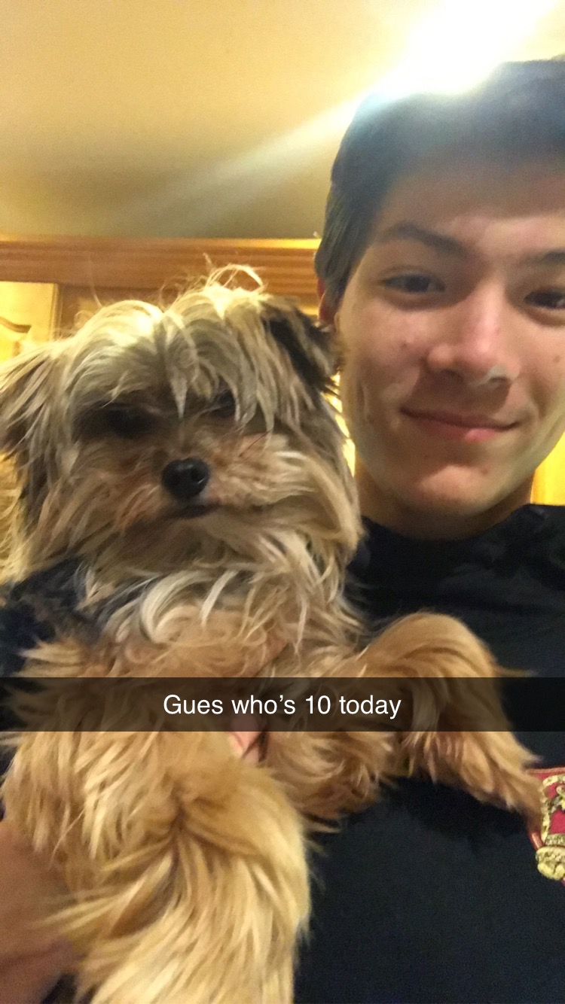
2. Jazz.png
3. Small cute fluffy Yorkshire Terrier held by a handsome man
4. Jazz is a small Yorkshire terrier who lives in Bedford Massachusetts. He is 12 years old.
5. Jazz spends most of his time lying on the couch. He doesn’t have the energy he used to have when he was younger. His favorite foods include cheese, steak, yogurt. He likes it when we mix steak juices with his kibble.
6. **Photo Gallery**
7. Jazz_cute.jpg
8. Jazz on a sunny day curled up on the porch
9. JazzSmile.jpg
10. Jazz smiling with his tongue out
11. MaDawg.jpg
12. Jazz lying in a laundry bin full of clothes
13. JazzSweater.jpg
14. Jazz in a grey and blue knit sweater
15. **Likes**
16. Food
17. Sleep
18. Going on walks
19. Dexter Kennedy

## Lincoln

1. 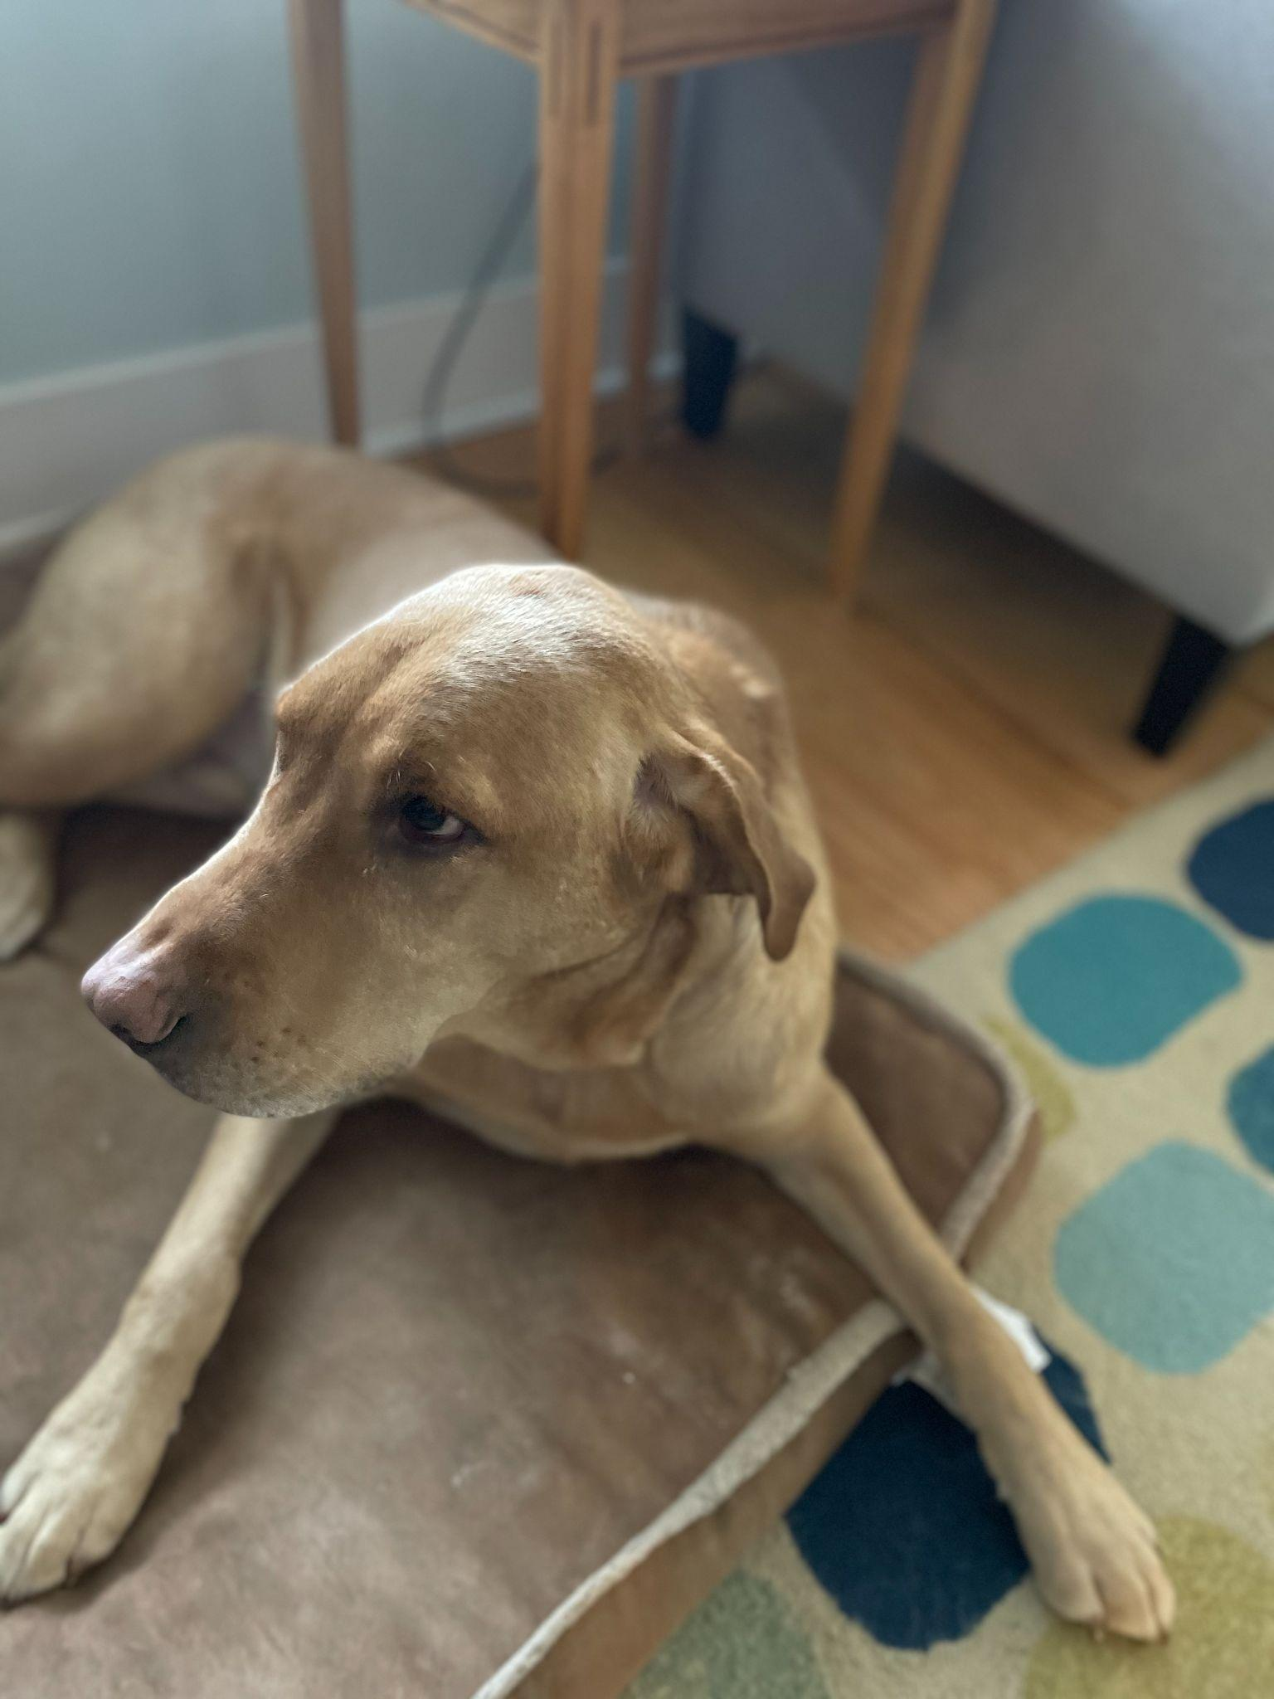
2. Lincoln_w.jpg
3. Yellow Lab
4. Lincoln is a very intellegent dog. There are times where i dont go pet him and you can see it in his eyes, he is holding a grudge. For the next hour or so he wont come whan I call him but will look at me with eyes that say, you did this. Another example of his intellegence is he is an ace at hide and seek, as well as other games a dog should not be able to play.
5. Lincoln is not a huge fan of his brother (my other dog), Rainier. When Rainier geats any form of attention, Lincoln will put himself into the scene and bark as if he is being mistreated. He is noit being mistreated, Lincoln is just a wimp.
6. **Photo Gallary**
7. Snow_dog.jpg
8. Picture of my dog walking in the snow
9. Dog_squad.jpg
10. Lincoln and his brother Rainier hanging out
11. Lincoln_car.jpg
12. Lincoln going for a ride in the car
13. Sleepy_dog.jpg
14. He's sleeping on his bed
15. **Likes**
16. Walks
17. Swimming
18. Rides
19. Jack Gaffney

## Bear

1. Primary Image of Pet
2. bear.jpg
3. A fluffy black, white, and tan Shiba Inu with pointed ears named Bear.
4. Bear is a lazy, food-loving dog that is sometimes playful. His favorite activity is lying in the sun on his side and lounging. He enjoys playing with his toys and loves to fetch them when you throw them, but eventually, he gets bored and just stops fetching them and lays down.
5. Bear is also scared of a lot of things. He doesn’t like water (showers and even rain) or getting his nails clipped, and he’s sometimes even so lazy that he’ll just stop walking and sit down until you turn around and go back home.
6. **Photo Gallery**
7. bear_squish.JPG
8. Bear is laying on his back with a squished face
9. bear_leash.jpeg
10. Bear on his back fighting with his leash
11. bear_lazy.JPG
12. Bear taking a break under a tree during a walk
13. bear_sunbathing.JPG
14. Bear sitting under a window in the sun
15. **Likes**
16. Food
17. Laying in bed
18. Fetch
19. Grace Zhu and John McCloskey

## York

1. 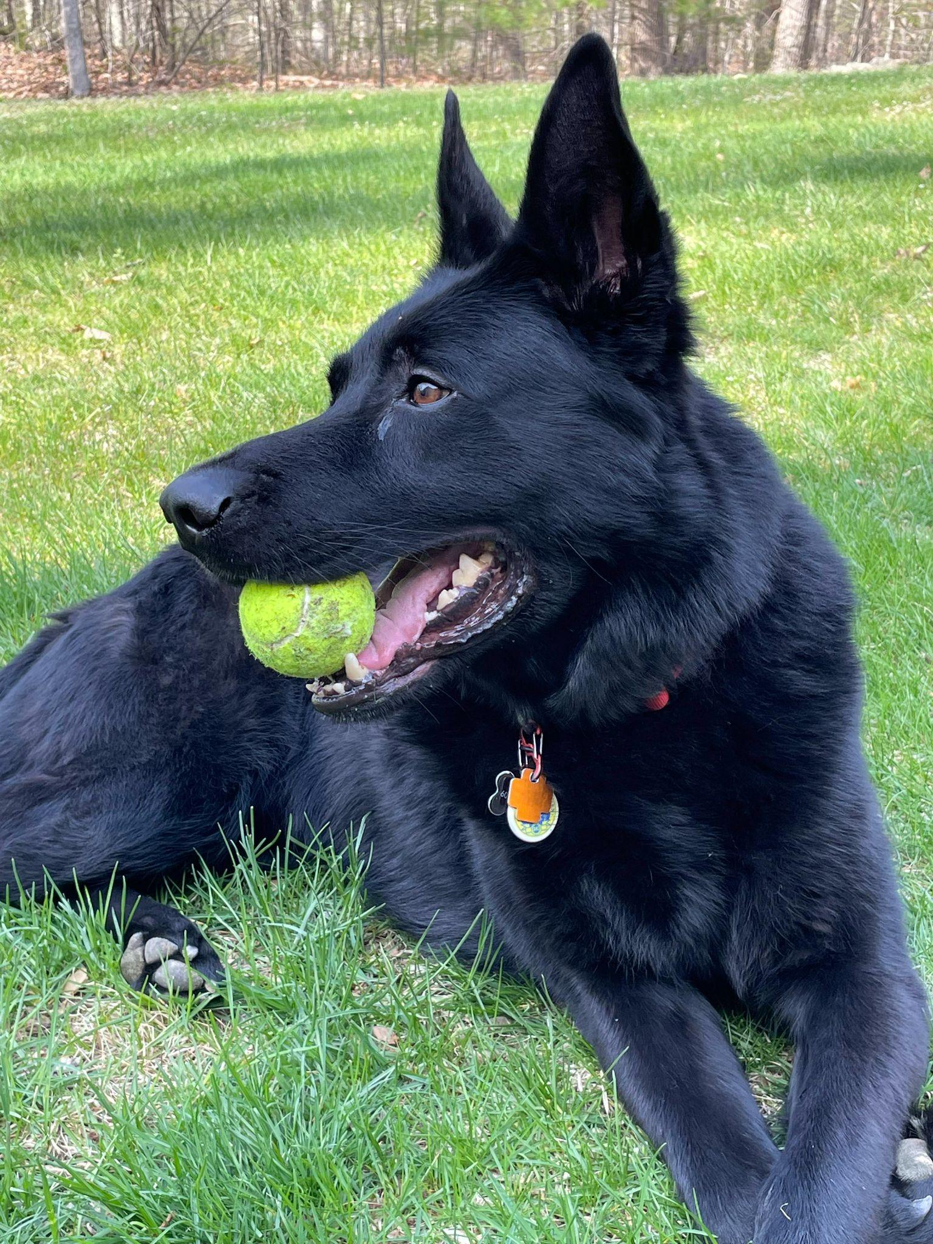
2. york.jpg
3. He is a large Black German Shepherd.
4. York loves to stay active and go on long walks by his house. He also enjoys chewing on his large assortment of toys. His favorite toy is his squeaky pig. York’s favorite food is sausage, but cheese is another favorite.
5. York is a very sociable dog and is a licensed therapy dog. He frequently visits nursing homes and other places in an attempt to raise peoples’ spirits. When it comes to bedtime, York prefers to sleep alone in his favorite blue dog bed. He will always be the first to get up in the morning.
6. Photo gallery
7. york2.jpg
8. York sleeping
9. york3.jpg
10. York on couch
11. york4.jpg
12. York chilling
13. york5.jpg
14. York eating yogurt
15. Likes
16. Food
17. Playing
18. Toys
19. Ben Montgomery

## Honey

1. 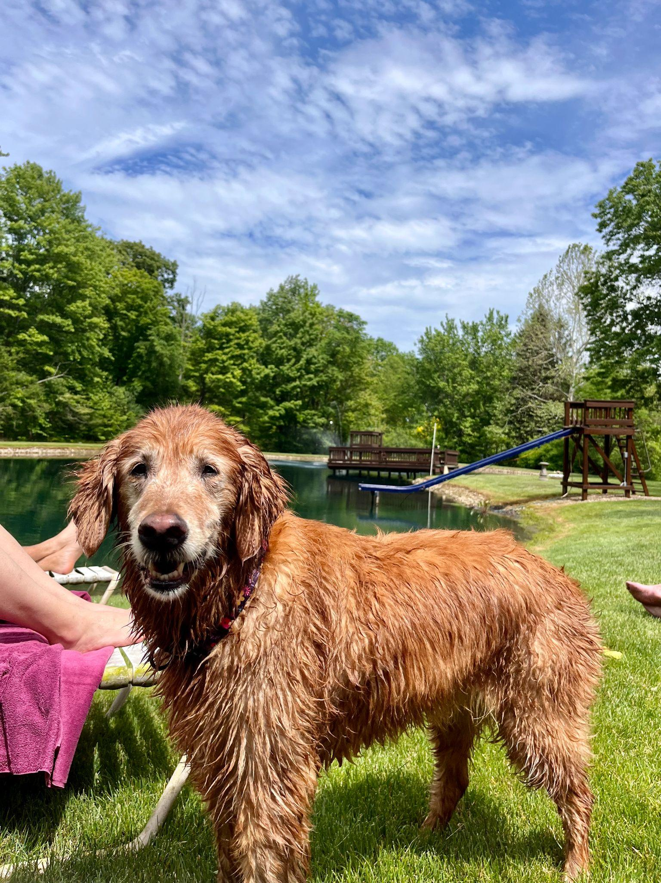
2. honey_main.jpeg
3. Honey is a medium-sized golden retriever with honey brown fur. She has a white patch of fur on her chest and her right eye is smaller than her left.
4. Honey’s favorite thing in the world is swimming. Even if it is the middle of January and half of the lake is frozen, Honey will be in the water. She is a smart swimmer, so when my brother and I go underwater, she will follow our air bubbles and be waiting for us when we come up for air.
5. While most dogs like to chase balls or sticks, Honey likes to chase rocks. She will even chase rocks into the water and stick her whole face in the water to try and find the rock thrown. Chasing rocks is her main form of exercise right now as she refuses to go on walks from our house. If we drive her to another spot and walk from there, Honey will go on a walk but she refuses to leave our driveway when we try to walk from home. Finally one other Honey-ism is that her safe place is bathtubs. Many times our family has woken up in the middle of the night and found Honey is a bathtub.
6. **Photo Gallery – (Just write Photo Gallery)**
7. honey_sleeping.jpeg
8. Honey taking a nap
9. honey_rock.jpeg
10. Honey playing with a rock
11. honey_swimming.jpeg
12. Honey swimming
13. honey_smiling.jpeg
14. Honey smiling
15. **Likes – (Just write Likes)**
16. Likes rocks
17. Likes food
18. Likes attention
19. Abbie Tooman

## Jingle

1. 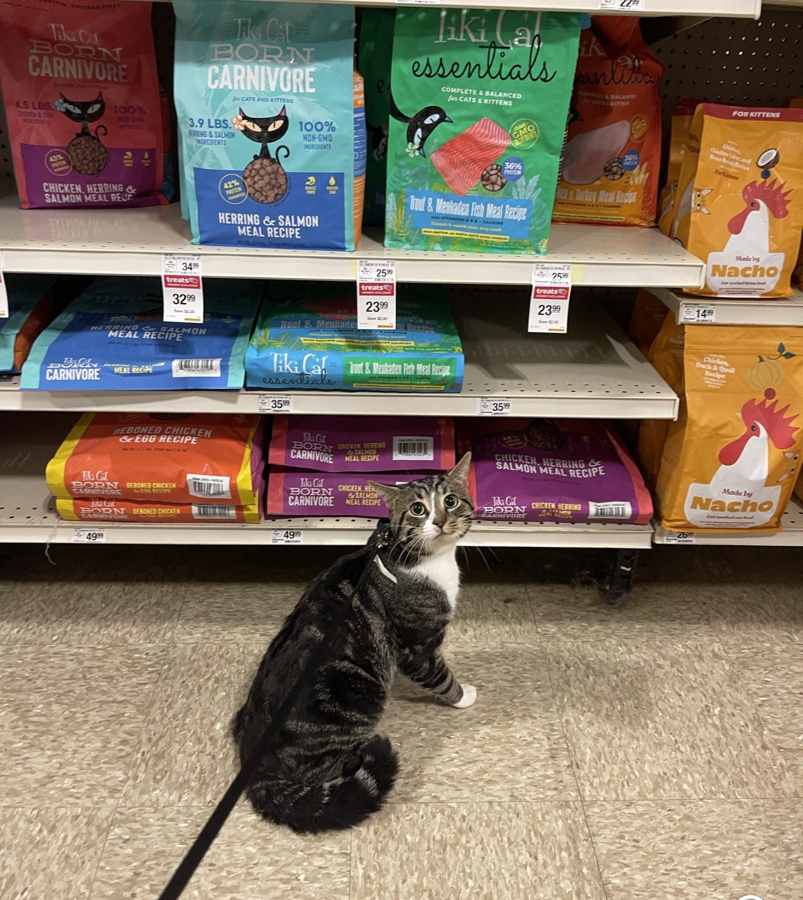
2. Jingle.jpg
3. Jingle is a domestic shorthair cat with a white chest and belly and a striped black and gray back. His paws are white and they look like mittens.
4. Jingle loves going outside. He used to be an outdoor/indoor cat until we realized that he loved to get injured. Now, we take him on walks with a leash which he loves! Every time he sees me carrying the leash he goes crazy and meows to go out.
5. Jingle is very mischievous, he has gotten into many different accidents. His first accident was outside; a bee stung his paw and he cried all night long. The second one was ALSO outside, he got stuck on a tree for four days. Finally, he came back home one day with his tail bleeding and ripped out.
6. **Photo Gallery**
7. jingle_outside.jpg
8. A close up picture of Jingle’s face outside.
9. jingle_flowers.jpg
10. Jingle sitting next to the flowers in our garden.
11. jingle_snow.jpg
12. Jingle in the snow.
13. jingle_window.jpg
14. Jingle watching the snow outside.
15. **Likes**
16. Going on walks.
17. Being pet
18. Eating treats
19. Lynn Sabieddine

## Maui

## 

1. maui.jpg
2. Name of file with pet picture (make sure to add the picture to the proper Google Drive!)
3. He is a mini doodle with brown/blond hair
4. Maui is a two-year-old mini-doodle who thinks he is as big as a German shepherd. This mindset allows him to voice his opinion, especially when demanding food or attention. He is also a classic momma's boy, as he has learned if he is annoying enough, he can get anything he demands.
5. During his lounging time, he gets to the highest chair he can get on and stares outside, waiting either for guests or belly rubs. He also has the tendency to force his mother to go to sleep as soon as his father goes to bed.

For the next four pictures you can just put the names of the files, you don't have to include the files in this drive, but you do need to add them to the proper Google Drive.

1. **Photo Gallery – (Just write Photo Gallery)**
2. maui2.jpg
3. Maui sitting under a table
4. maui3.jpg
5. Maui’s head on a counter
6. maui4.jpg
7. Maui sitting on the highest chair he can get on
8. maui5.jpg
9. Maui not being apologetic
10. **Likes – (Just write Likes)**
11. Car rides
12. Being chased
13. Sitting in high places
14. Antonio Lieghio

## Luna

1. 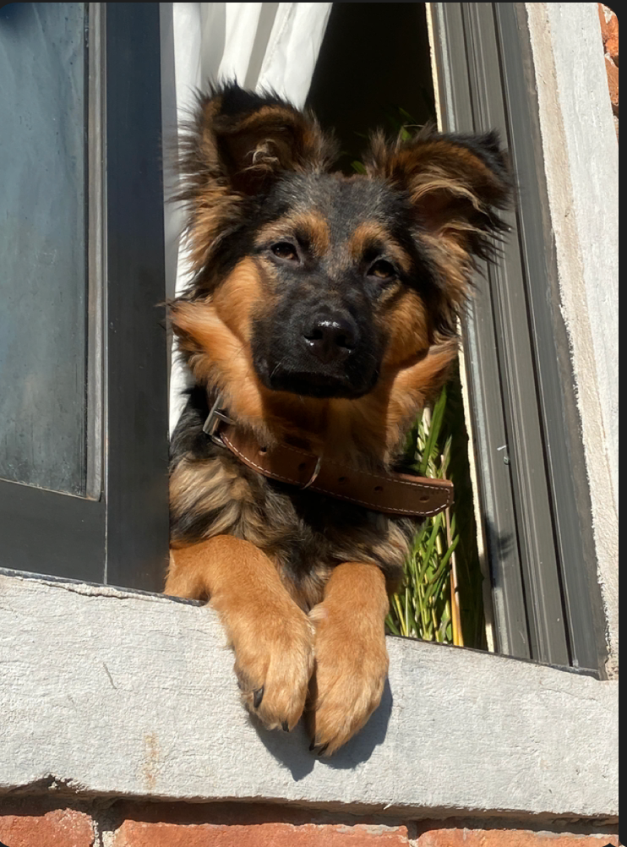
2. Luna.PNG
3. Mini German shepherd sunbathing
4. Luna is a German shepherd mix and a fireball of energy. Oftentimes, destroying anything in her path she will take and hide all your socks, shoes, and clothes for her to chew on. She loves playing catch at the park, it always gives her the zoomies.
5. Luna is a very jealous, loving, and protective dog. She really embraces her inner chihuahua and will bark at any stranger, car, or noise at night. She makes the perfect guard dog. But she is not at all aggressive. Luna is all bark no bite!

For the next four pictures you can just put the names of the files, you don't have to include the files in this drive, but you do need to add them to the proper Google Drive.

1. **Photo Gallery – (Just write Photo Gallery)**
2. luna_puppy.PNG
3. Luna as a puppy
4. luna_napping.PNG
5. Luna’s afternoon nap
6. luna_friends.PNG
7. Luna, Lobi, Laith
8. luna_evil.PNG
9. Luna death stare
10. **Likes – (Just write Likes)**
11. Chicken
12. The Park
13. Belly Rubs
14. Jahaira Flores

## Carter

1. 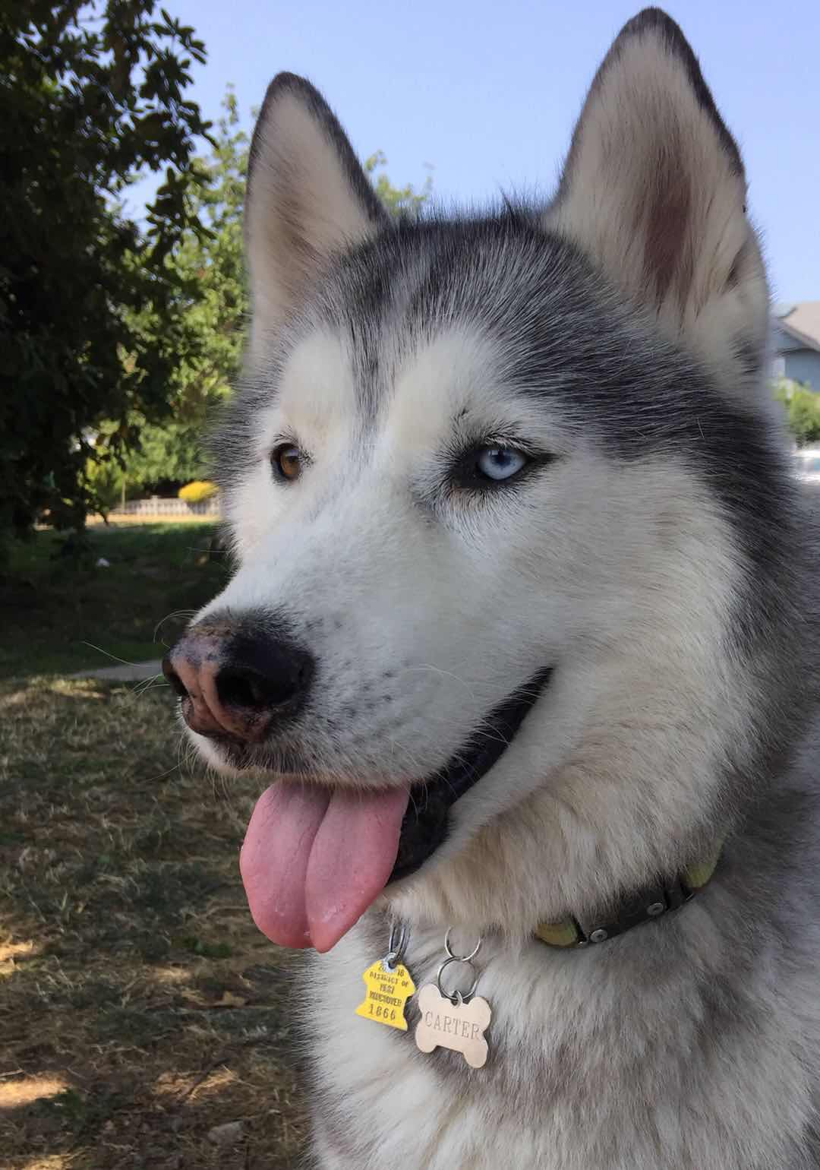
2. carter.jpeg
3. Carter is a husky with black, gray, and white fur. One of his eyes is blue, while the other one is brown. His nose is black but red in the middle. His fur is very fluffy and thick.
4. Carter was born in Seattle. However, my brother bought him and brought him to Boston. Whenever my brother did not have time to walk Carter, he would put him on the treadmill. When Carter became too much of a responsibility for my brother as a college student, he took Carter to Vancouver to live with my mom, sister, and me. Because we lived in the mountains, he would sometimes howl in the middle of the night whenever he saw a wild animal.
5. Whenever I threw him a ball, he ran to the ball but never brought it back to me. He would sometimes escape the backyard of our house if we forgot to close the gates by accident. Even if we looked for him everywhere and did not find him, he knew the way home and always came back in the end. He loved going to the forest and the beach. He had his own spot on the living room couch and would television with us if he was bored or tired.

For the next four pictures you can just put the names of the files, you don't have to include the files in this drive, but you do need to add them to the proper Google Drive.

1. **Photo Gallery**
2. carter_young.jpeg
3. Carter when he was only a few months old
4. carter_canada.jpeg
5. Carter’s look on Canada Day
6. carter_forest.jpeg
7. Carter playing and staring into the forest
8. carter_beach.jpeg
9. Carter at the beach in front of his name
10. **Likes**
11. Treats
12. Beach
13. Forest
14. Anca Fu

## Basil

1. 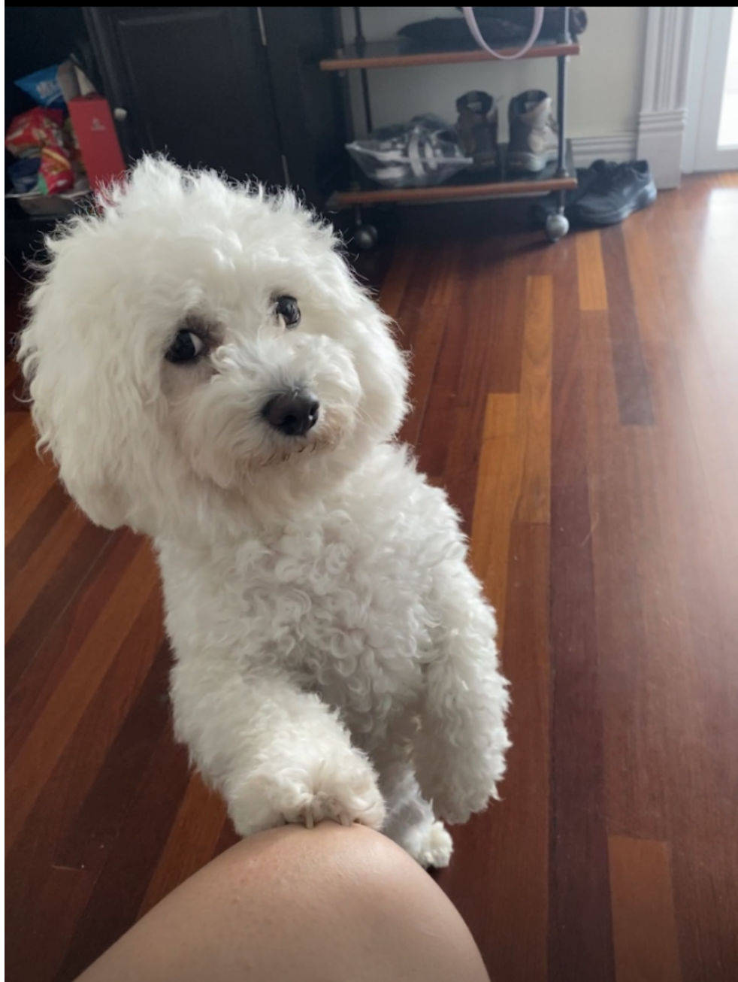
2. gurl_who_u_looking_at.png
3. Fluffy white dog with paw on knee, begging for attention and giving you the side eye
4. Basil, otherwise known as Slaysil, is a very energetic white, slightly crusty and trusty, dog (bichon) . She gets princess treatment in her household, but also out in public. As a consequence, she is very clingy and loves to lick, especially in the face.
5. She endeavors in multiple hobbies and activities, which include flying, licking, standing on two legs, ringing bells, and jumping through hula hoops.

For the next four pictures you can just put the names of the files, you don't have to include the files in this drive, but you do need to add them to the proper Google Drive.

1. **Photo Gallery**
2. naruto_basil.png
3. White bichon in a naruto robe (Akatsuki)
4. balloosil.png
5. Balloon attached to white bichon
6. pet_me.png
7. White bichon leaning against leg
8. superbasil_HOP.png
9. White bichon floating in air while running
10. **Likes**
11. Empty water bottles
12. Socks
13. Cats
14. Bianca and Alina

## Finn

1. 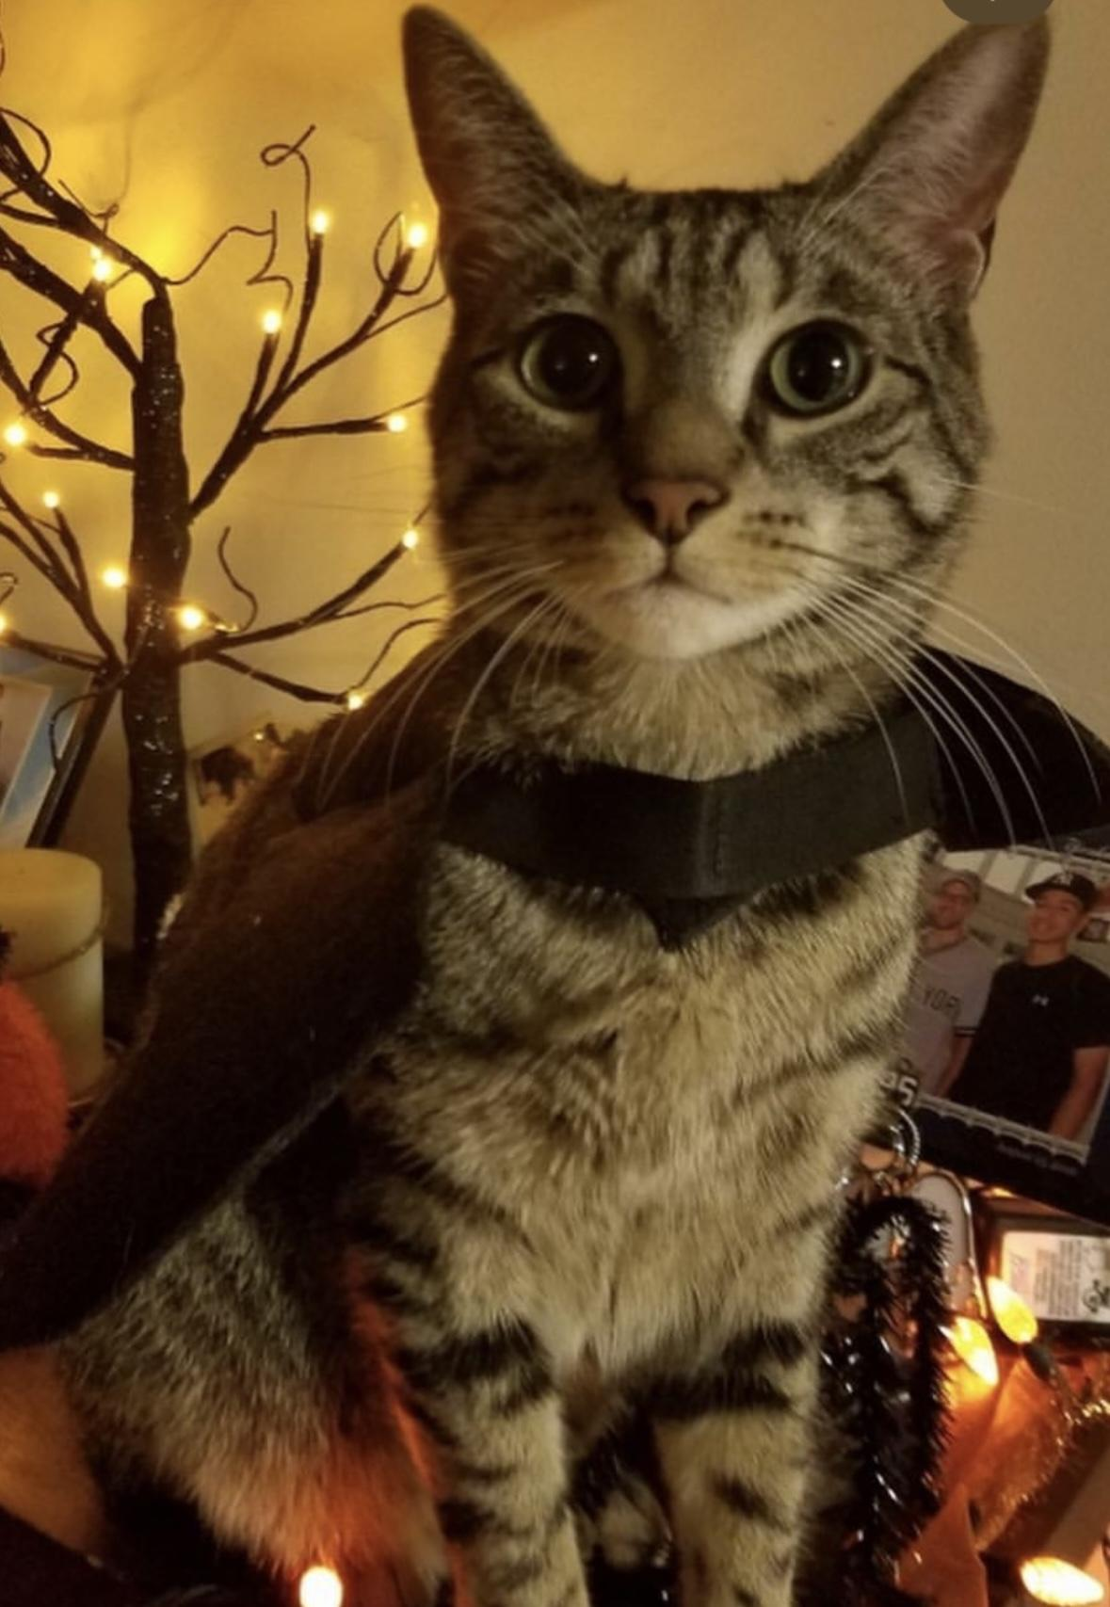
2. Finn_Halloween.jpg
3. Finn wears a bat costume for halloween
4. Finn is a 7 year old grey cat. I feel like no one really knows cat breeds so I’m just gonna go with grey. He loves doing tricks for treats and his favorite is giving high fives to people. He might as well be a dog as he loves the outdoors and meeting new people. I can only describe him as goofy and chaotic.
5. Finn’s biggest enemy is his vet. I don't know whether or not it’s because his vet is an MSU alum, but he doesn’t like him. He actually has to be prescribed a sedative before he goes to the vet office because he’ll suddenly act like he was never a house cat for 7 years.
6. Finn_Shlumped.PNG
7. Finn is exhausted after a long day of absolutely nothing.
8. Finn_Kitten.jpg
9. A few days after we adopted Finn. He’s just posing for the camera
10. Finn_GOAT.PNG
11. Finn dressed up as the king he is for Halloween
12. Finn_Goldenhr.PNG
13. Finn showing off his green eyes during golden hour

Likes:

1. Treats
2. Head Rubs
3. Sleeping in cardboard boxes
4. Lauren Rodriguez

## Terry

1. 
2. terry_sitting.jpg
3. Black dachshund wearing leash and sitting.
4. Terry is a playful and spirited dachshund that loves to play fetch with his bone or tennis ball. He loves wandering in forests and finding large sticks to take home. His favorite foods are kibble and peanut butter. Terry will run around frantically when it’s time to eat at home.
5. My family found Terry at a shelter and decided to adopt it. He was 4 months old and is now 8 years old. Terry knows how to swim, but we don’t tend to go often. Terry got poison ivy once; however, he quickly recovered and has been doing great since.
6. **Photo Gallery**
7. terry_beach.jpg
8. Black dachshund wearing sunglasses at a beach.
9. terry_stick.jpg
10. Black dachshund holding stick at lake on rocks.
11. terry_minion.jpg
12. Black dachshund wearing a Minion costume.
13. terry_reed.jpg
14. Black dachshund holding a reed on street.
15. **Likes**
16. Fetch.
17. Eating.
18. Belly rubs.
19. Alex Mitchell and Matthew Inda

## Milo

1. 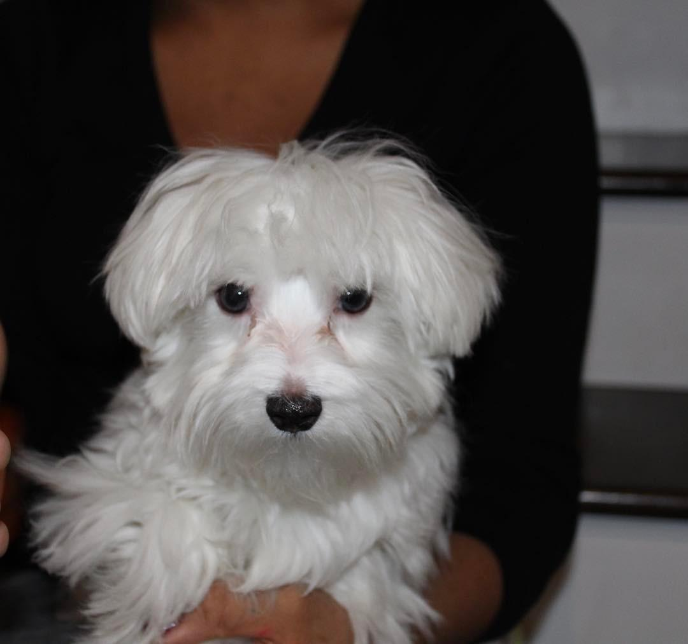
2. milo.jpg
3. Milo, an 8 year old white Maltese family pet
4. Milo, a bashful yet warm-hearted dog, holds a deep appreciation for social interactions, whether they involve humans or fellow pets. Having spent his entire life with the same loving family, Milo's consistent displays of loyalty reflect his strong sense of familiarity and connection. He's known for his charming quirks, such as his penchant for taking a few steps backward instead of a simple turn when changing direction.
5. Despite his shyness, Milo's keen senses come to the forefront. At the sound of a passing car, his bark, though more bark than bite, resonates beyond the walls of the house. Interestingly, Milo has never quite grasped the concept of navigating stairs, yet he remains remarkably perceptive about his surroundings. It's this unique blend of traits that makes Milo an endearing presence, leaving a lasting impression on those fortunate enough to share in his companionship.

For the next four pictures you can just put the names of the files, you don't have to include the files in this drive, but you do need to add them to the proper Google Drive.

1. **Photo Gallery**
2. milo_puppy.jpg
3. A snapshot of Milo during his puppy days.
4. milo_xmas.heic
5. A picture of Milo donning a festive look with his fur dyed in vibrant green and red shades, celebrating the Christmas spirit.
6. milo_adidas.jpg
7. Milo wearing an "Adidog" shirt, a take on the popular Adidas brand.
8. milo_car.heic
9. An image capturing Milo sitting in a dog car seat in the rear of a vehicle.
10. **Likes – (Just write Likes)**
11. Bacon
12. Socks
13. Attention
14. Cameron Nichols

## Lucy

1. 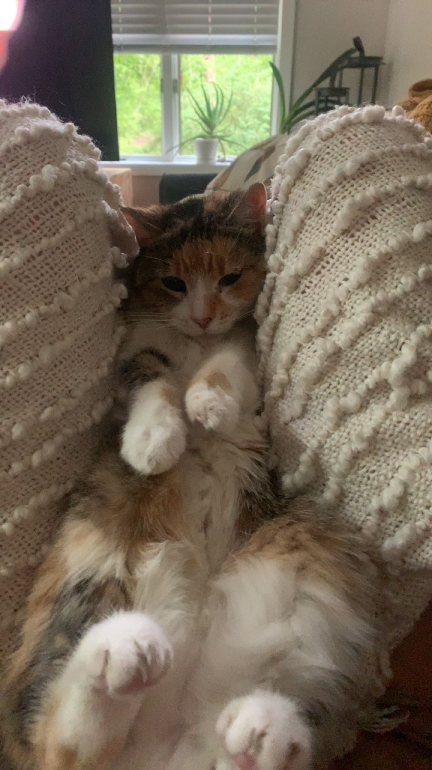
2. Lucy.jpg
3. Calico with white, orange, and black coloring
4. Lucy is a 17-year-old calico that I’ve had since I was 5, she has pretty much grown up with me my whole life. Even though she’s old she’s still kickin’ it and enjoys running around the house at 4am.
5. Her favorite foods include anything but her kibble. She enjoys sunbathing and long naps, along with lots of petting. However, she hates getting her stomach rubbed.

**Photo Gallery**

1. lucy_upsidedown.jpg

Lucy laying on her back

1. lucy_sleeping.jpg

Lucy curled up in her bed sleeping

1. Lucy_sleepingpt2.jpg

Lucy curled up sleeping

1. Lucy_laying.jpg

Lucy laying staring at the camera

**Likes**

1. Sleeping
2. Food
3. Her bed
4. Maggie Holman

## Molly

1. 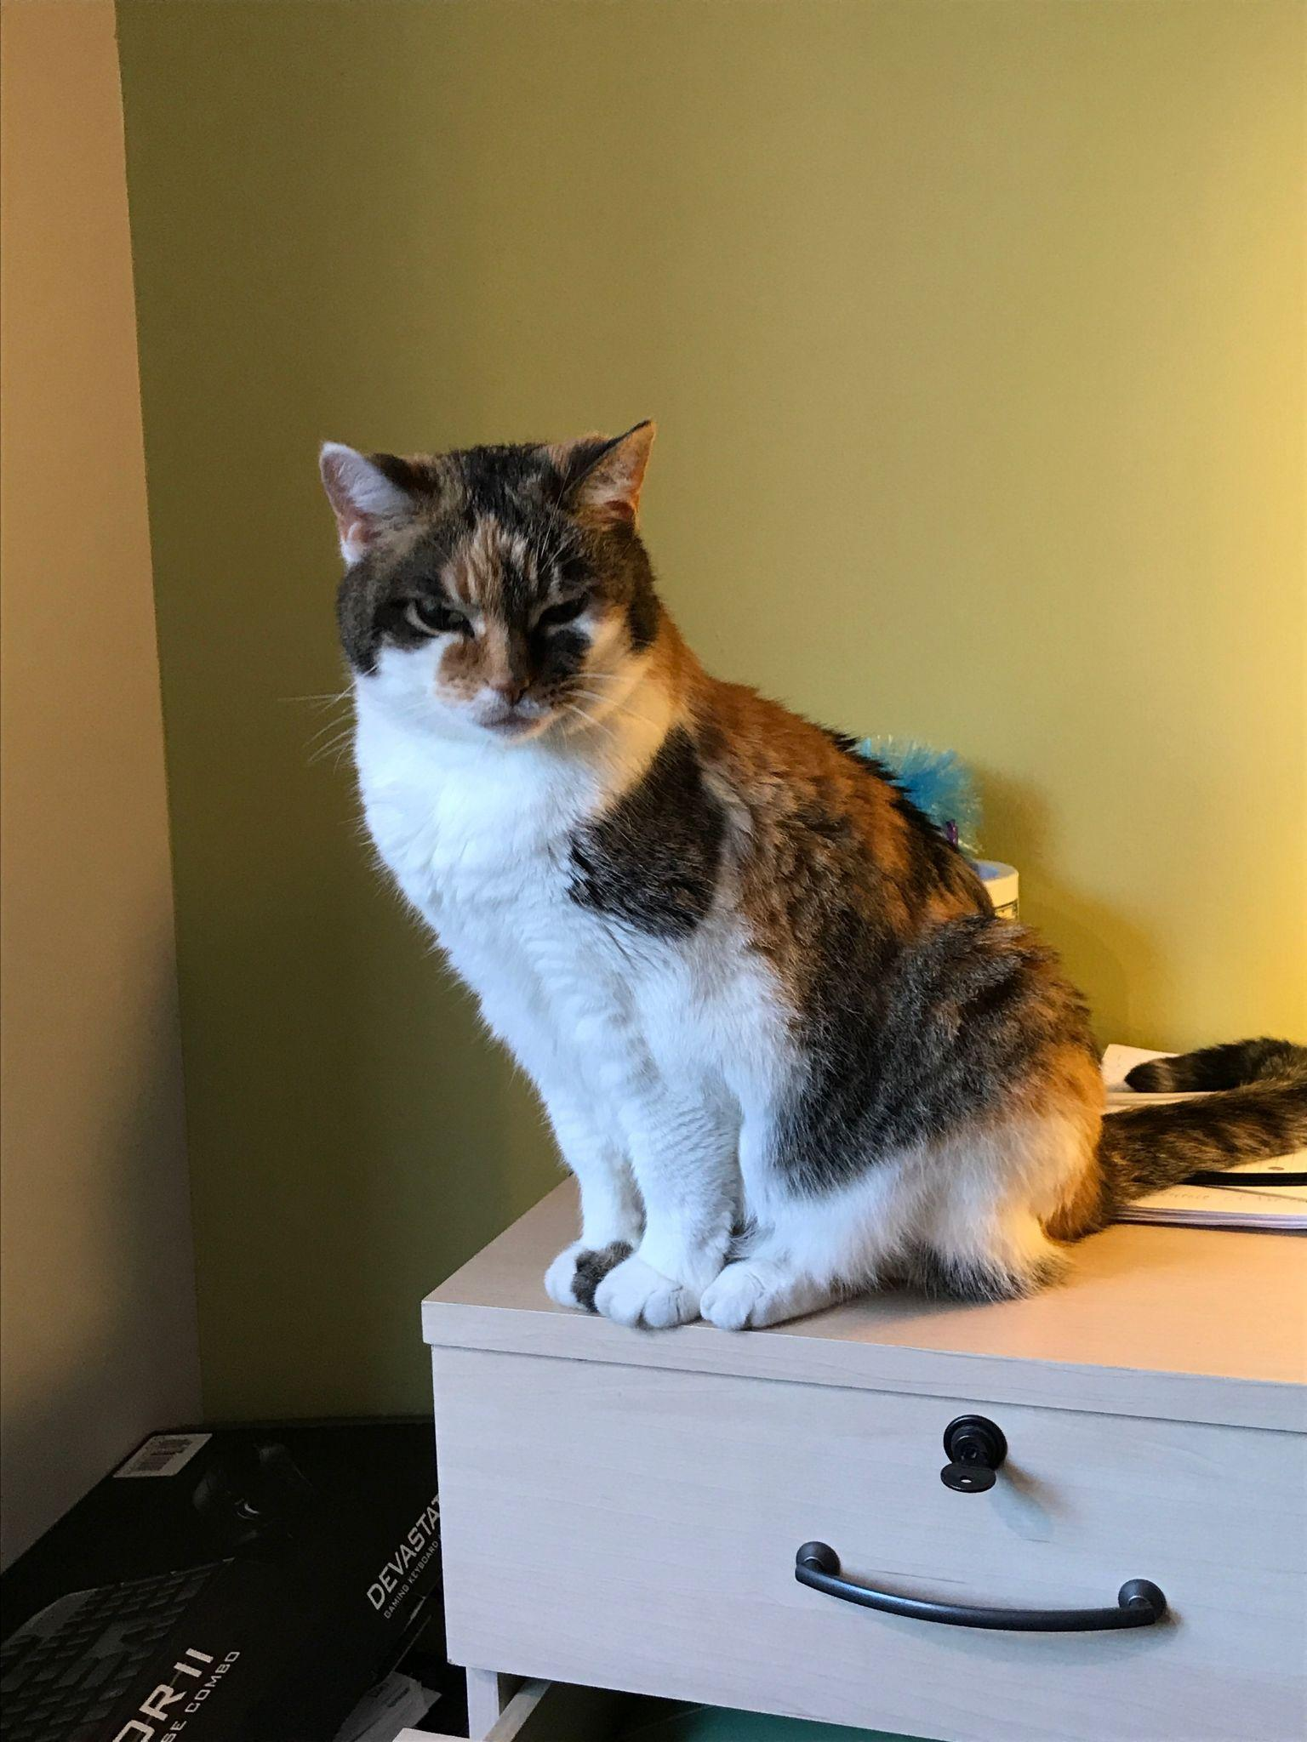
2. molly_on_cabinet.jpg
3. Calico cat with orange, white, and black coloring sitting on cabinet
4. Molly is an 18 year old calico cat. She prefers spending her days lounging on the couch or curled up sleeping over a vent (or anything warm). Occasionally, she’ll go outside and attempt to hunt birds or rats (sometimes successful which is terrifying).
5. Molly’s favorite habit is to brush against people’s legs, especially during dinner when everyone is seated around a table. She’s an attention seeker, always meowing to get as many pets and head rubs as she possibly can.
6. **Photo gallery**
7. molly_on_pc.jpg
8. Molly sleeping on a warm pc
9. molly_scratching_paper.MOV
10. Molly trying to tear up a sheet of paper
11. molly_climb_chair.jpg
12. Molly trying to climb a chair to receive pets and head rubs
13. molly_sunbathing.jpg
14. Molly enjoying warm rays of sunshine
15. **Likes**
16. Scratching couches
17. Sunbathing
18. Brushing against people’s legs
19. Jonathan Chen
20. Daisy
21. 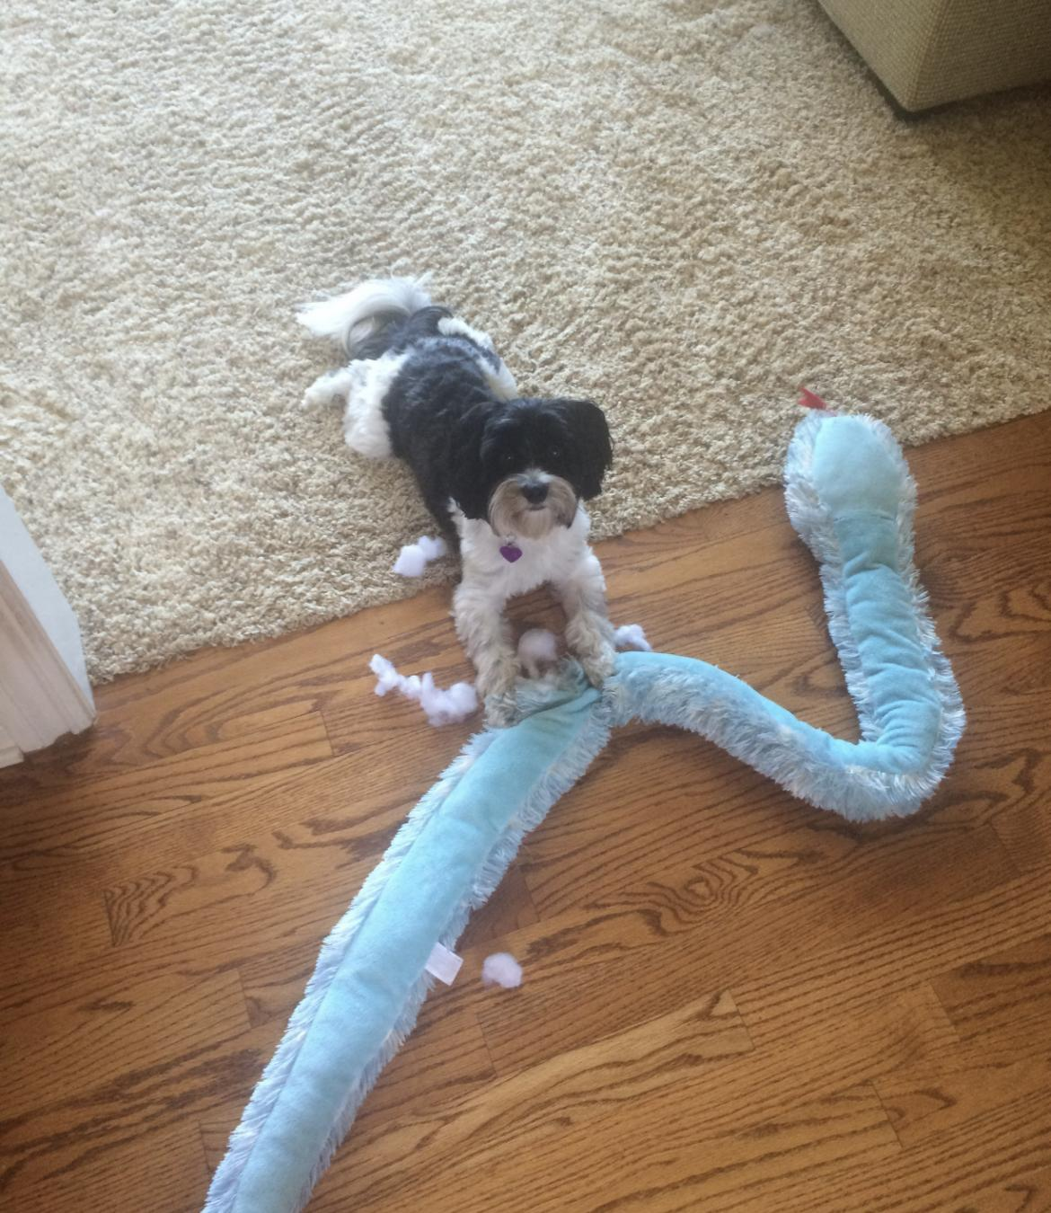
22. daisy_defeats_snake.jpg
23. Daisy is an 8 year old black and white Morkie (Maltese-Yorkie)
24. When Daisy isn’t busy slaying all of the evil snakes trying to attack us (Pictured Above), you can usually find her annoying her older sister Marina, getting super hyper at completely random times, or relaxing in our backyard making sure she keeps out all of the intruders (squirrels)
25. One of Daisy’s favorite things to do is beg to go on a walk, and then once we’re about half way done with the walk she likes to lay down and refuse to keep going. She then loves being carried all the way back from said walk, and the process will repeat again later in the day.
26. **Photo Gallery**
27. daisy_closeup.jpg
28. Very Close up image of daisy
29. daisy_tired.jpg
30. Daisy is slumped after a long day of walks
31. daisy_festive.jpg
32. Daisy in her halloween costume with her sister Marina
33. daisy_disposable_camera.jpg
34. Picture I took of daisy with one of my disposable cameras
35. **Likes**
36. Shredded Cheese
37. Walks around the neighborhood
38. Peanut Butter Chex Cereal
39. Luke Brusseau

## Pappy

1. 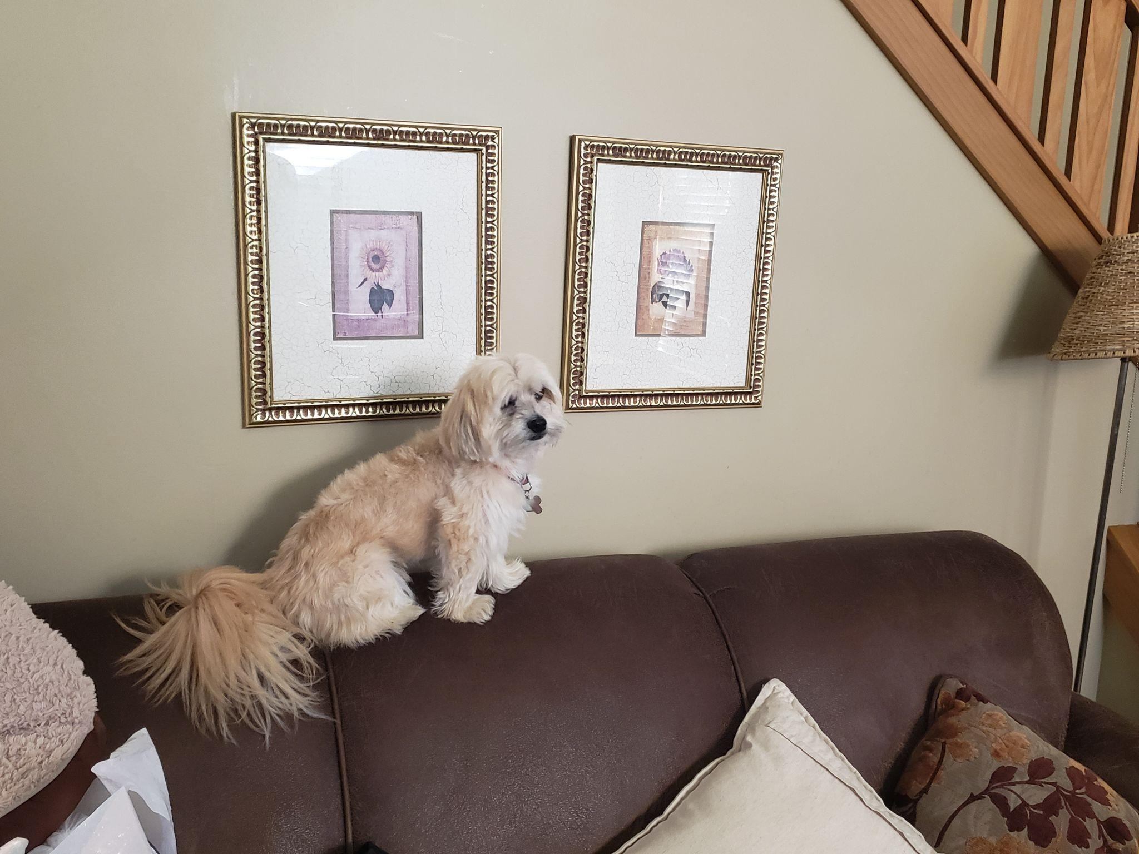
2. couch_pappy.jpg
3. Tan Morkie sitting on couch
4. Pappy is a 7 year old morkie. Most days he prefers to spend it laying around the house in his various favorite spots. Most of the time you can find him lying in his bed. He loves going with walks, but still hasn’t figured out how to approach other dogs without scaring them off. He loves his family and loves to keep intruders away even for his size.
5. He also enjoys playing with his favorite basketball. He loves pushing it around, scratching it, or even talking with it. He also loves his little stuffed animal too. Pappy also loves to be scratched and will ask you to keep scratching until he is happy.
6. **Photo Gallery – (Just write Photo Gallery)**
7. sun_pappy.jpg
8. Pappy taking in the sun on a sun chair
9. hiding_pappy.jpg
10. Pappy hiding in his favorite spot when he was younger
11. glasses_pappy.jpg
12. Pappy putting on “his glasses” to read a book
13. popsicle_pappy.jpg
14. Pappy enjoying a homemade popsicle on a hot summer day
15. **Likes**
16. Taking naps with his paws in the air
17. Getting scratches or belly rubs
18. Any kind of dog treats
19. Brian Cereceres

## Mocha

1. 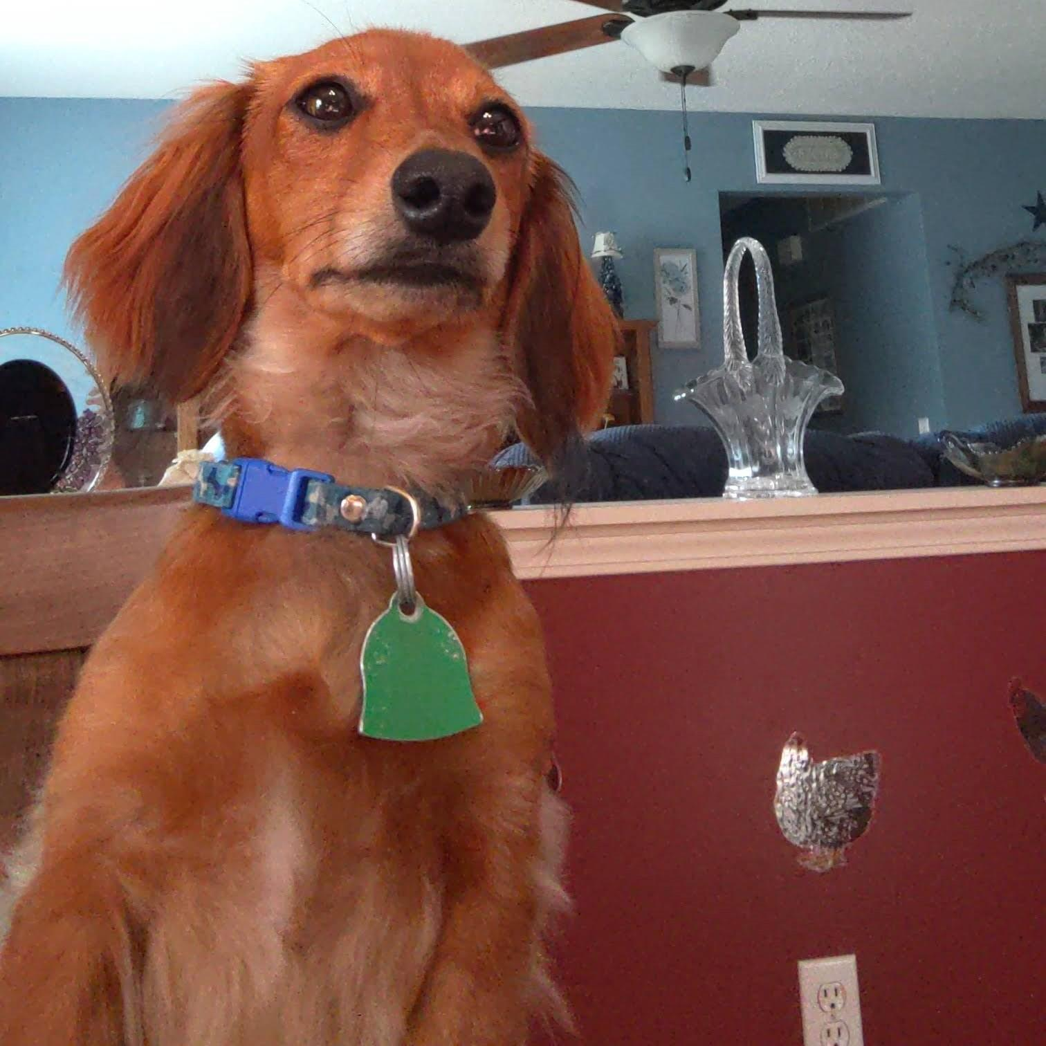
2. mocha.jpg
3. An upright dachshund with light brown fur and a blue collar staring behind the camera.
4. Mocha is a very energetic little dog. His favorite activities are tug-of-war with toys, playing fetch with his orange ball, and laying on his dad’s lap. He has so much energy that in the evenings he tends to ‘get the zoomies’ in which he sprints in circles around the house without any stimulation.
5. When Mocha is done playing, he loves to lay down in an especially silly way. He lays on his belly with his rear paws pointed straight backwards as shown in the following photos. It’s his favorite way to recharge after a long day of play.

For the next four pictures you can just put the names of the files, you don't have to include the files in this drive, but you do need to add them to the proper Google Drive.

1. **Photo Gallery**
2. mocha_posture.jpg
3. A dachshund sitting upright in a person’s lap with its paws resting on a table that it stares across.
4. mocha_laying_cement.jpg
5. A dachshund laying belly-down with its rear paws pointed backwards on cement pavement.
6. mocha_laying_carpet.jpg
7. A dachshund laying belly-down with its rear paws pointed backwards on a blue rug.
8. mocha_football.mp4
9. A dachshund on its hind legs nipping at a football held by a person.
10. **Likes**
11. Jumping on and off the couch
12. Running in circles
13. Belly rubs
14. Andrew Wilks-Millard

## Luke

1. 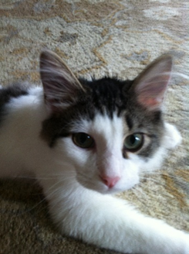
2. Luke.jpg
3. Luke is a white cat with long hair and brown spots.
4. Luke is a six-year-old white cat; he is very energetic and likes to play fetch. Luke has one brother named Jesse. Luke’s favorite thing to eat are chicken cat treats.
5. Luke is very badly behaved. He often jumps up on furniture and drinks out of people’s water glasses. He also steals people’s jewelry and hides it in his bed. Luke knows several commands; he can sit, jump, follow, play fetch, and give people his paw.
6. **Photo gallery**
7. Luke.JPG
8. Luke looks into the camera; only head and front paws are in frame.
9. luke_reads.JPG
10. Luke sits on chemistry textbook.
11. luke_in_sunn.JPG
12. Luke sits on a white bench in front of a window, grass is seen behind him.
13. luke_yawns.jpg
14. Luke lays on his back on a gray blanket and yawns.
15. **Likes**
16. Luke likes salmon.
17. Luke likes to play fetch with hair ties.
18. Luke likes to sleep in laundry baskets.
19. Katherine Isseks al-Abadi Hattersley

## Millie

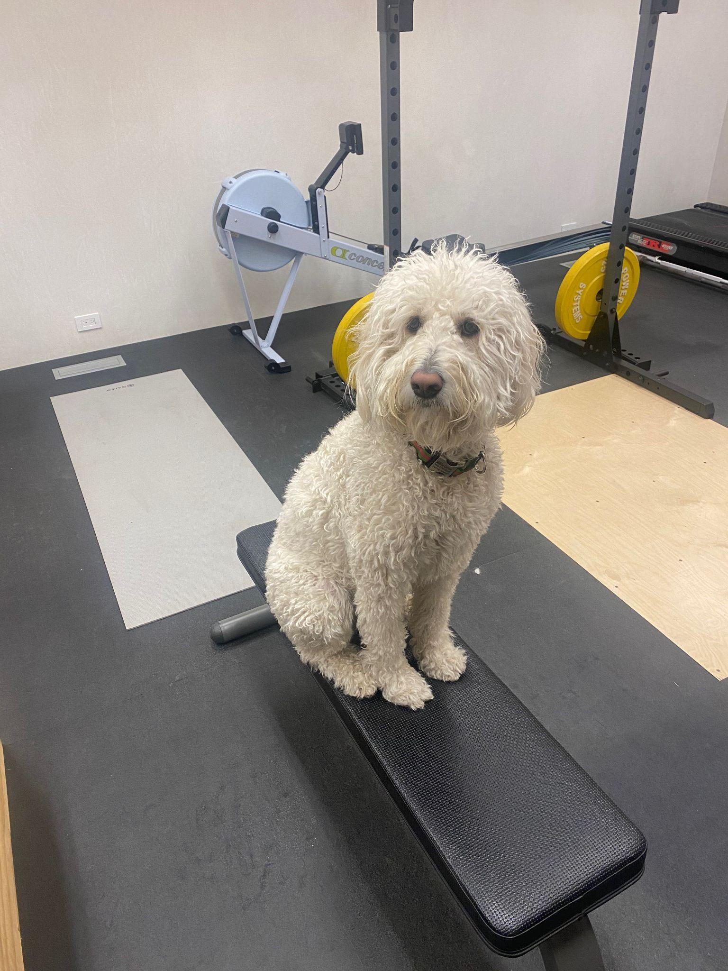

1. millie.jpg
2. Millie a fluffy white dog with curly hair, medium to large size
3. Millie is an English Cream goldendoodle but sometimes is described as a human in a dog suit. She loves cuddles and can speak if you tell her to. She always wants to be around people and lays in bed on her back like a person.
4. Millie is eager to go on walks and runs but is very out of shape. When we get to the final hill of each run she is way behind, she will nap for hours a day but then bounces up and down if she sees bunnies or squirrels.
5. **Photo Gallery**
6. Mturkey.jpeg
7. Millie with a turkey costume on
8. Mbench.jpeg
9. Millie sitting on a park bench
10. Mlap.jpeg
11. Millie in her moms lap
12. Mshoulder.jpeg
13. Millie on her sisters shoulders
14. **Likes**
15. Outfits
16. Her mom,
17. Bunnies
18. Emma Ezrine

## 

## Bob

1. 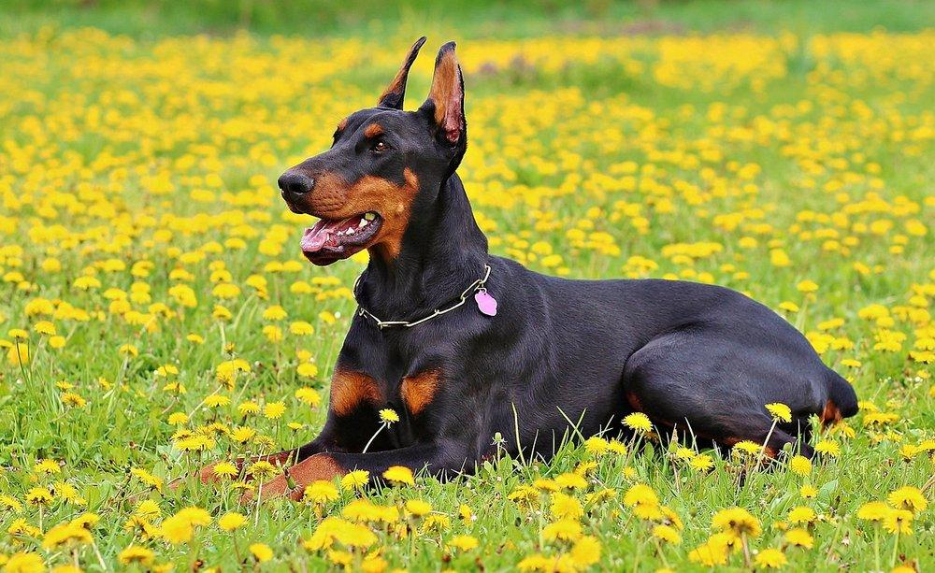
2. doberman.jpeg
3. Bob is a black Doberman wearing a collar with a pink flower.
4. Bob is from Michigan. He loves to go on walks and visit the dog park. He loves the beach and playing fetch. He is 4 years old and still acts like a puppy at times.
5. Bob’s favorite food is steak. He likes medium rare. He will do tricks for it, which includes rolling over. He also likes to chase squirrels up trees and go for runs with his owner. Bob does not like cats and his best friend is a Pitbull names john.
6. **Photo Gallery**
7. Stick.jpeg
8. Black Doberman with stick in mouth
9. fetch.webp
10. Doberman leaping into air, catching frisbee
11. runner.jpeg
12. Doberman very happily running fast
13. Sleeper.jpeg
14. Doberman sleeping in a goofy way
15. **Likes**
16. Playing Fetch
17. Swimming
18. Chasing squirrels
19. Kyle and Hudson’s pet

## Banana

1. Image: 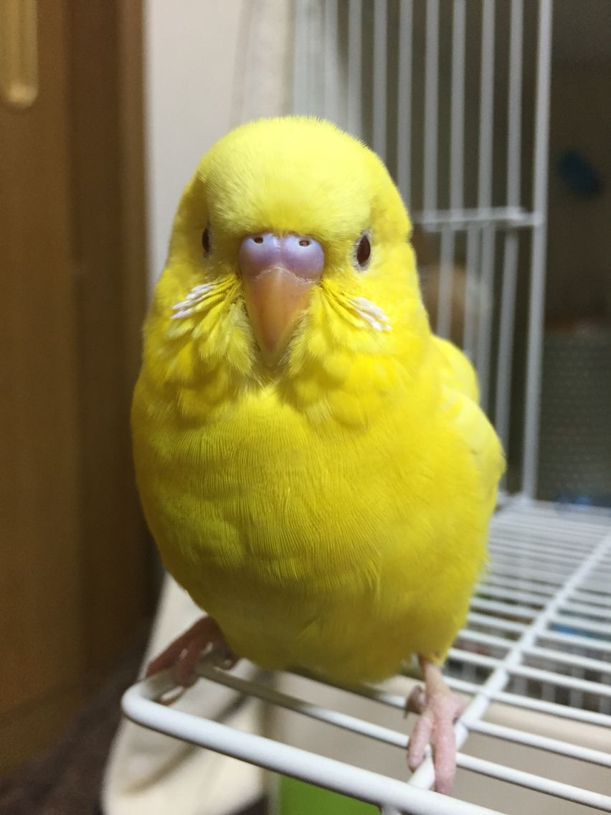
2. Name of file with pet picture (FN): banana.jpeg
3. Visual Description: Behold a charming creature with a vibrant yellow body that's irresistibly cute. Its rounded form and large, playful eyes exude a joyful and approachable vibe, instantly warming hearts and spreading positivity.
4. The pet is a budgie, a wonderfully social and cool animal. Initially, the bird might be a bit scared and require training. This process usually takes about 2 weeks of gradual interaction within its cage to help it become comfortable and accustomed to your presence. Afterward, you can progress to more direct approaches like placing your hand on the cage and offering treats from your hand.Once they've grown comfortable, the experience becomes quite enjoyable. Budgies thrive on social interaction and attention, delighting in playtime and engaging with people. They're open to learning tricks and can even be taught to talk due to their intelligence.
5. Budgies make fantastic pets; they're incredibly cute and delightful to observe. However, they can be a bit chirpy, especially in the mornings, which might be a bit bothersome. Yet, this is just their way of seeking attention and expressing themselves positively. As companions, budgies are truly rewarding. Building a bond with them requires time and patience, but the process is well worth it. Once they grow comfortable with you, the satisfaction of training and connecting with them is truly fulfilling.
6. **Photo gallery (4):**
7. FN: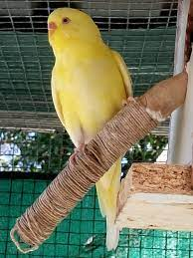
8. VD: fly.jpeg
9. FN: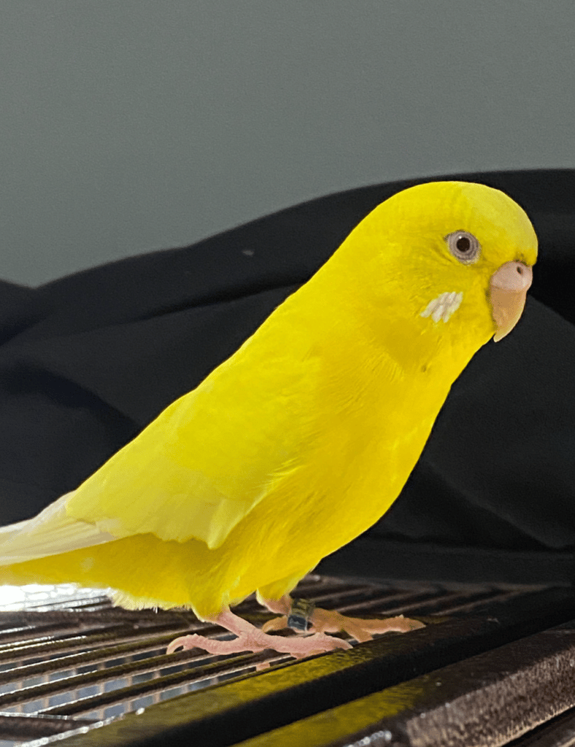
10. VD: majestic.png
11. FN: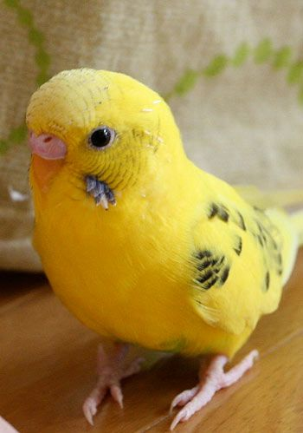
12. VD: yellow.jpeg
13. FN: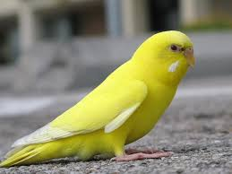
14. VD: ana.jpeg
15. **Likes**
16. To chirp a lot
17. Fly around room
18. Perch on hand
19. Playing in birdy playground
20. Abdouaziz Jom

## Bo

1. 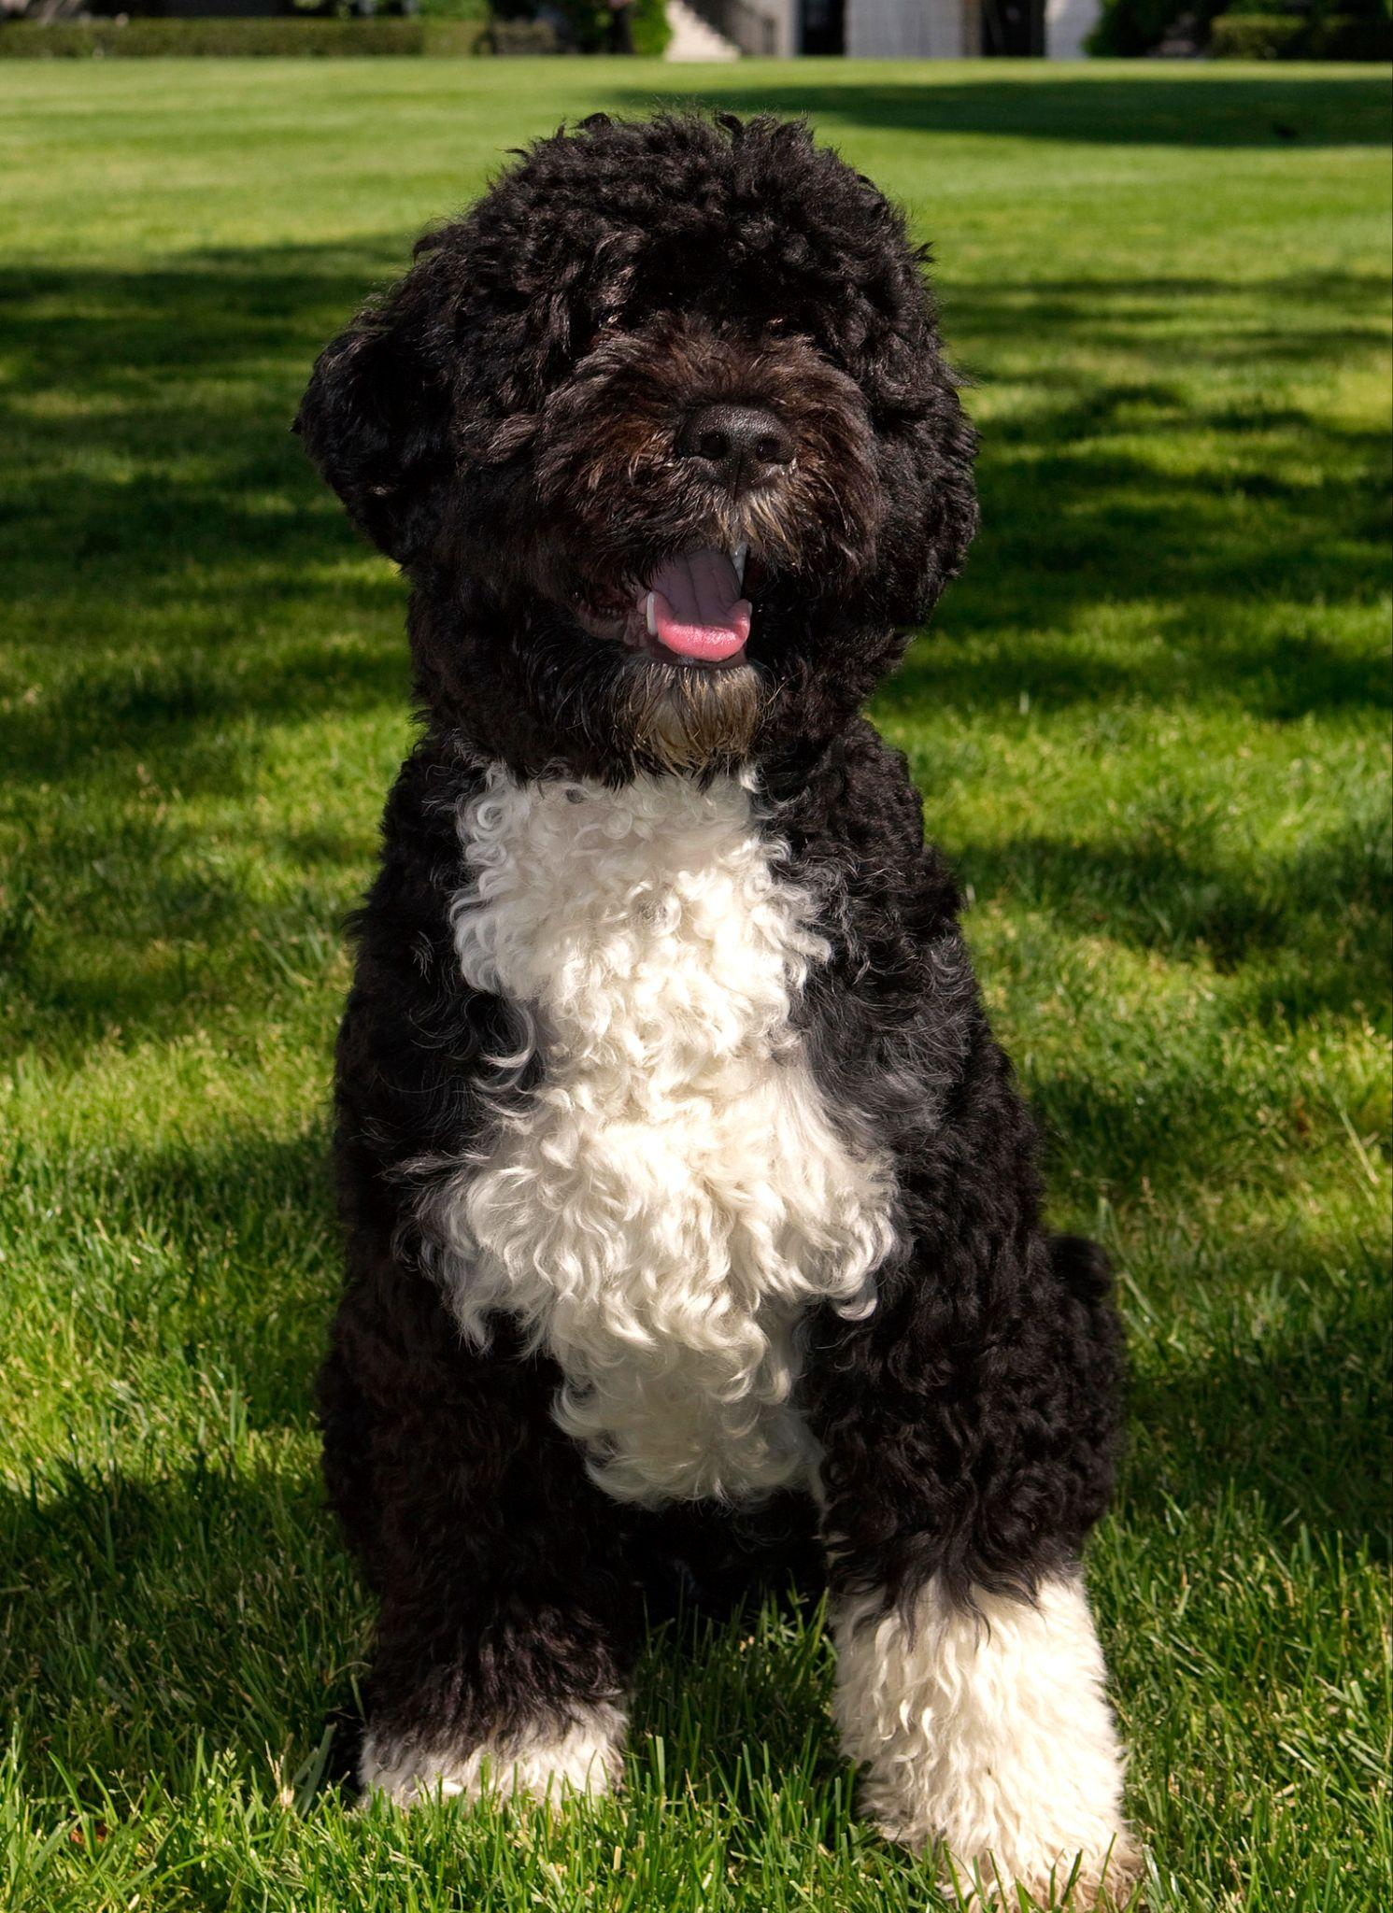
2. bo.jpg
3. Black and white dog sitting on grass
4. Bo is a Portuguese Water Dog with black and white fur. His paws are white too, so they always get dirty when outside. He is 12 years old, but he still likes to run around outside a lot.
5. He has an abundance of toys but only likes to play with a couple. He enjoys going on walks and especially on trails in the woods. He has a few dog friends that he likes to go on playdates with as well.
6. **Photo gallery**
7. bo_walking.jpg
8. black and white dog walking on grass
9. bo_and_friend.jpg
10. black and white dog sitting by other black dog
11. bo_plane.jpg
12. black and white dog in front of airplane
13. bo_chair.jpg
14. black and white dog sitting on top of chair
15. **Likes**
16. Walks
17. The Sun
18. Treats
19. Dogs
20. Joseph Schaubroeck

## Rosie

1. 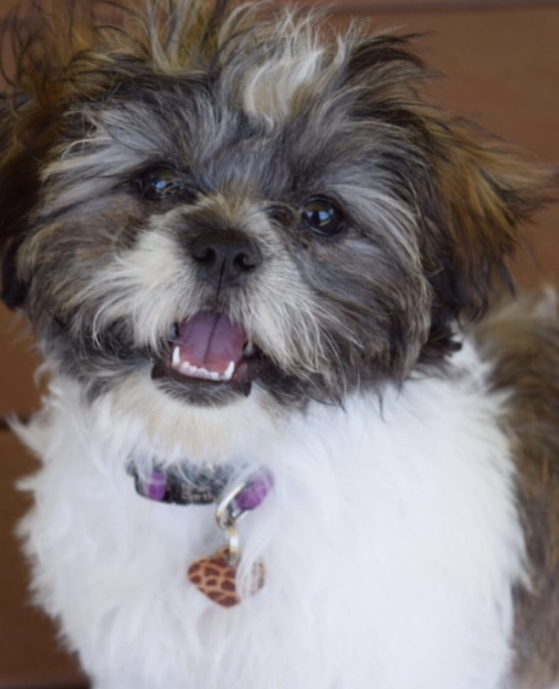
2. rosie.PNG
3. Brown and White Bichon/Shitzhu mix
4. Rosie is a small but super energetic dog. Whenever someone comes to the house she is very quick to run up and greet them. She loves to play fetch and will not leave you alone with her toys as she begs you to play with her.
5. Rosie is also a wonderful lap dog. If you sit on the couch she is quick to find a spot next to you. If you wear a blanket over your legs, you’ll find her laying on your legs. She loves to cuddle and loves to be pet so she will always be right up on you.

For the next four pictures you can just put the names of the files, you don't have to include the files in this drive, but you do need to add them to the proper Google Drive.

1. **Photo Gallery – (Just write Photo Gallery)**
2. rosie_sleeping.HEIC
3. Rosie sleeping upside down
4. rosie_blanket.HEIC
5. Rosie sleeping in between someones legs
6. rosie_table.HEIC
7. Rosie laying on table
8. rosie_towel.HEIC
9. Rosie wrapped in a towel
10. **Likes – (Just write Likes)**
11. Treats
12. Fetch
13. Cuddles
14. Ethan Lee

# Rocky

1. 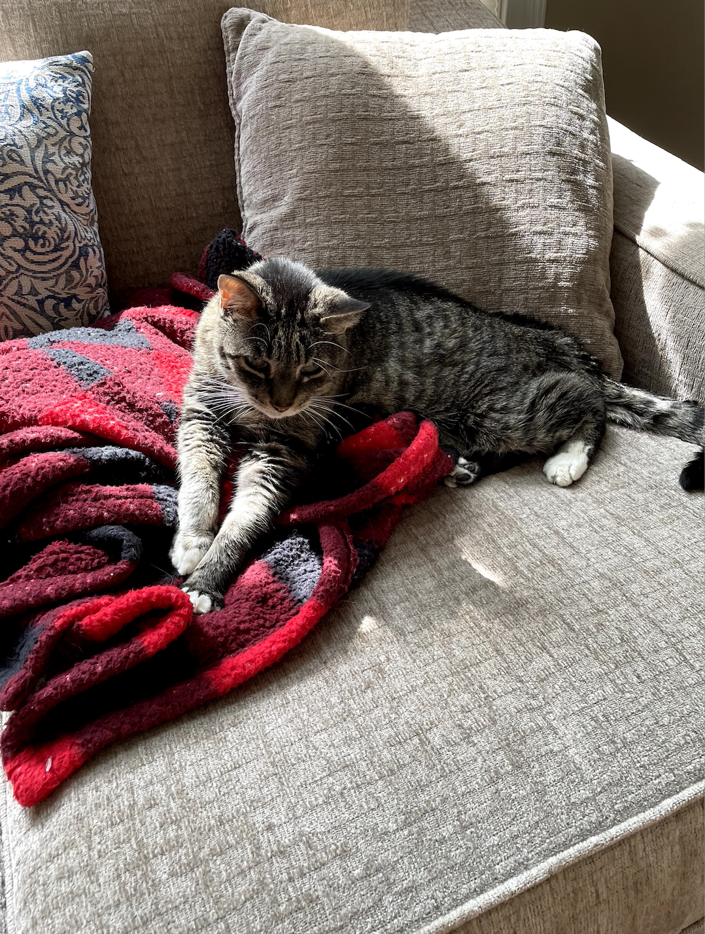
2. rocky.jpg
3. Black cat laying on red blanket
4. Rocky is a 17 year old cat who enjoys spending his time laying around. He likes watching birds and trying to talk to them. While he loves birds from afar, he is not a fan of any other animals and enjoys terrorizing the dog, Oliver.
5. Rocky is also a big fan of eating. He will do anything for a treat and likes any and all foods. He will gladly sneak onto the dinner table to sample any and all foods. If he doesn’t enjoy eating the food, Rocky is fine with playing with it instead.
6. **Photo Gallery**
7. rocky_treats.jpg
8. Cat sticking his head in treat bin
9. rocky_bird_watching.jpg
10. Cat looking out the window
11. rocky_hand.jpg
12. Cat sleeping holding hand
13. rocky_sleeping.jpg
14. Cat sleeping
15. **Likes**
16. Eating
17. Sleeping
18. Attention
19. Lauren Pesce

**1. Ador**

2.

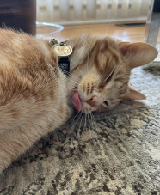

3. ador.jpeg

4. Large orange tabby cat with a small narrow face, a tiny tongue, and a long tail.

5. Ador is 1 year old. He is a very vocal cat who loves to be petted on his head. Ador

enjoys wrestling with his sister Maya, who is a few months older than him. During Ador’s free time, he enjoys looking out the window to see birds and occasionally squirrels in our neighborhood who stop by to say hi to him!

6. Ador is also very shy and timid. He doesn’t like to be in social situations and tends to hide behind a couch or run down to the basement. Though, once you get to know Ador, he is very affectionate and will often lick your hand when you pet him. Ador’s favorite snack flavors are chicken and turkey, and if you give him enough treats he will thank you for it vocally with his meows!

**7. Photo Gallery – (Just write Photo Gallery)**

8. ador_sunkissed.jpeg

9. Orange tabby cat under the sunlight.

10. ador_question.jpeg

11. Orange tabby cat sitting upright with head tilted to the right.

12. ador_sleep.jpeg

13. Orange tabby cat sleeping on a ledge.

14. ador_headrub.jpeg

15. Orange tabby cat laying on a couch being petted on the head.

**16. Likes**

17. Dry treats

18. Cuddling

19. Sleep

20. Reshad Alam

## MiaoMiao

1. 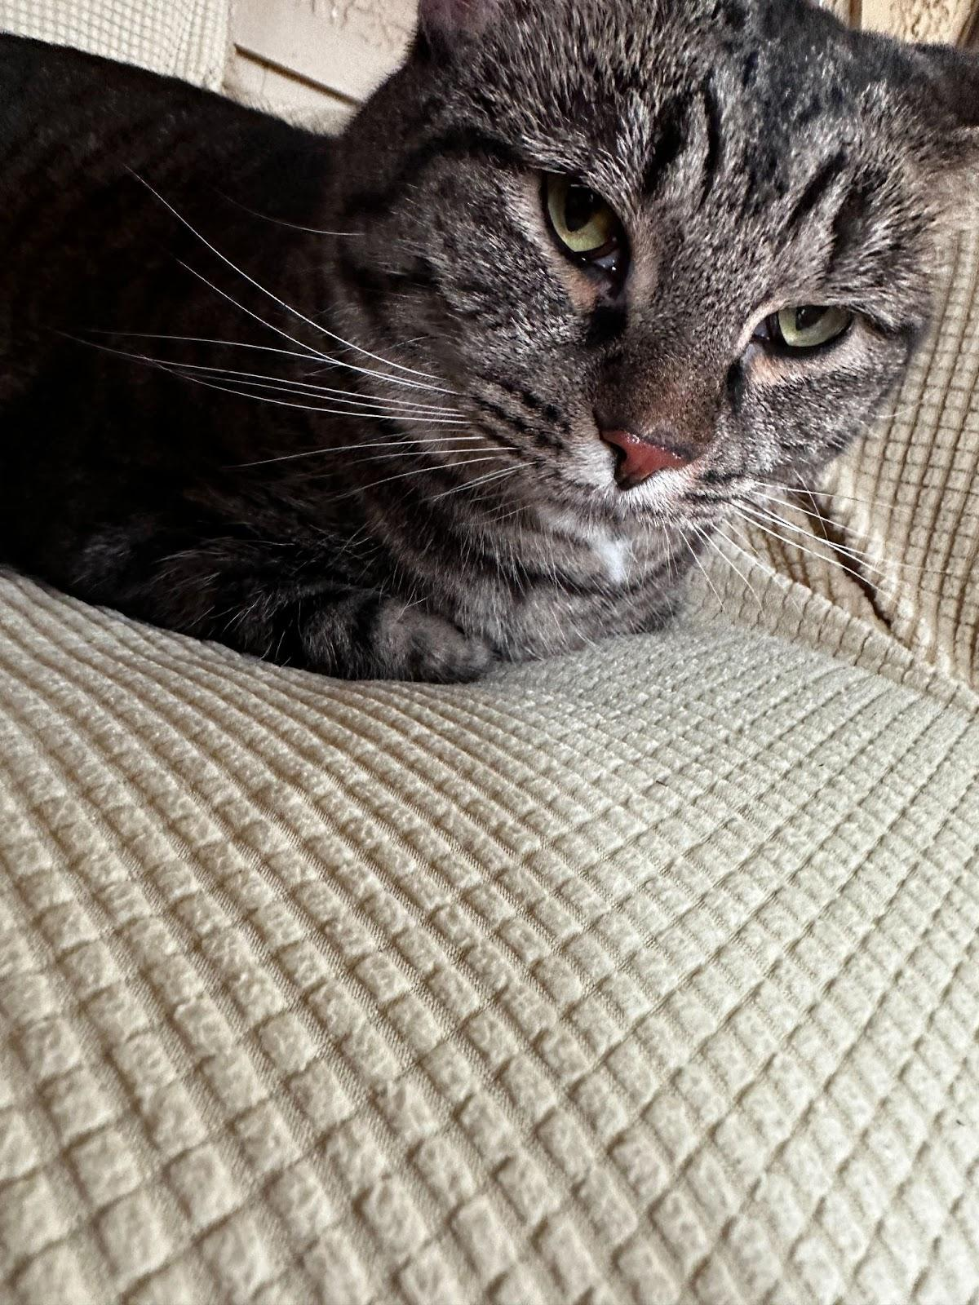
2. IMG_3088.JPG
3. A picture of MiaoMiao resting on her divine throne. A black striped with a hint of silver and brown staring at the camera with green eyes. Has paws under her body.
4. MiaoMiao is the best cat in the world, extremely social with other, and vigilant against strangers. Oftentimes you can find her running around the house looking for things to eat. If she consumed anything other than cat food, she immediately throws up.
5. She is chill and chirpy. Loves to play with anything other than professional cat toys. Prefers DIY entertainment. Pikachu,neo,Wild.When I wake up they are Chirping wildly and flying around in the house. Very social birds love when people hold them, put your hand out so they can fly to your palm.
6. *PhotoGallery*
7. V1 Michigan 339
8. PetCore
9. V1Animals Photo collage of all V1 Pets
10. V1 Pets United
11. V1/Pets
12. V1 Empire
13. V1 PetFood
14. Wild Videos V1 Pets
15. Likes
16. Anything DIY MiaoMiao
17. Bird Core : Likes chirping and running around
18. MiaoMiao Likes socializing with humans.
19. Kevin wang ,Zachary Abdirahman

# Zack

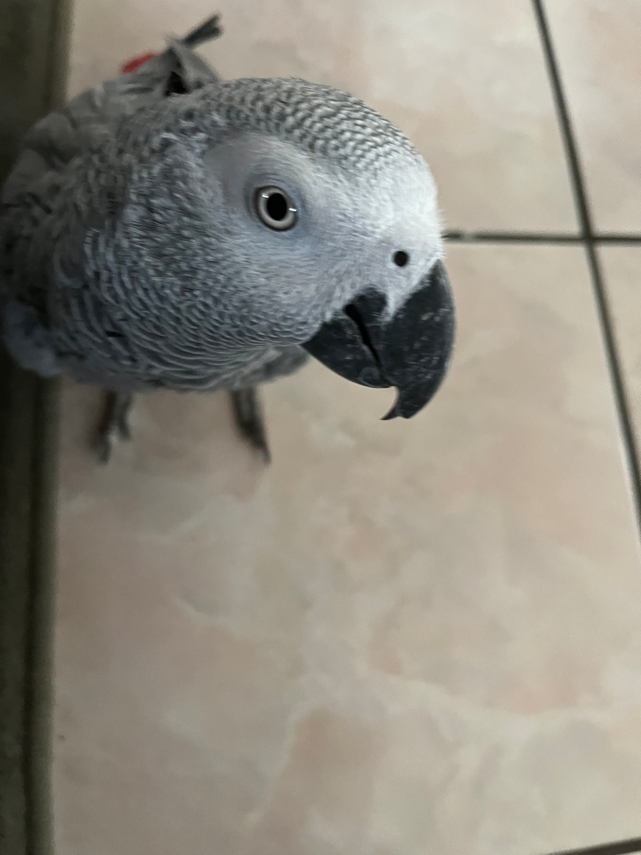

1. zamzam4.jpg
2. African grey parrot, 3 years old, red tail, and standing on kitchen tile.
3. Zack is an African grey parrot, aged around three years old. Zack loves flying and being outside of the cage at all times. He’s very nice but bites so much.
4. Zack’s favorite foods are unsalted sunflower seeds and mangos. He loves being able to sit on people’s shoulder and talking to them. Zack knows over 500 words and learns more everyday.
5. **Photo Gallery**
6. zamzam1.jpg
7. Zack on his cage standing.
8. zamzam2.jpg
9. Zack standing on his cage door, staring into the camera.
10. zamzam3.jpg
11. Zack standing on a rug staring up towards the camera.
12. zamzam5.jpg
13. Zack cleaning himself standing on top of the cage by his toys.
14. **Likes**
15. Sunflower seeds
16. Flying
17. Going on walk
18. Mohamedhussin Najaf

## Yugi

1. 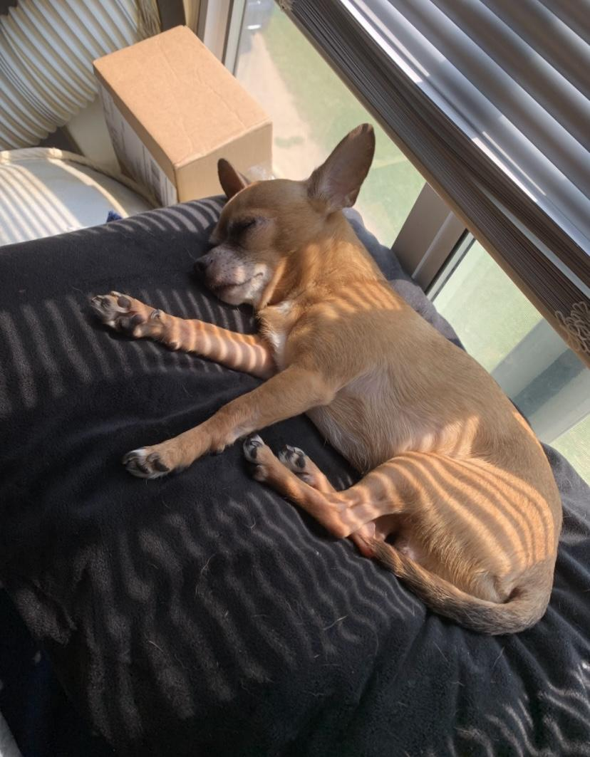
2. yugi_sleepa.jpg
3. Tan chihuahua sleeping on a black pillow
4. Yugi is a 7 year old chihuahua who loves love and adores attention. A member of the sassy dog community, he is full of personality and character with a response for everything. Nicknamed King Yugi, he holds himself as a true royal and leader of the home, being given all the luxuries in life by his humans.
5. With the ability to love beyond his small body, Yugi is an attached lap dog that loves to be your sidekick. Protective, caring, and cuddly, there is never a time he isn’t there to support you and is always prepared for a short-notice nap time.
6. **Photo Gallery**
7. yugi_sun.PNG
8. Yugi sunbathing
9. yugi_eyes.HEIC
10. A close up photo of natural light highlighting Yugi’s eyes.
11. yugi_nom.JPG
12. Yugi chomping on a finger
13. yugi_baby.JPG
14. Yugi as a chubby puppy sleeping
15. **Likes**
16. Cuddling
17. Sleeping
18. Doing tricks for treats
19. Aileen Gonzalez

## Bacon Q Dog



1. bacon.jpg
2. Brown labradoodle wearing colorful lei
3. Bacon Q. Dog is a 9yr old labradoodle. He prefers to spend his days lounging among the three different beds/couches that his family has gifted him. He enjoys a walk or two around the neighborhood, as long as he can pretend that he doesn't see any of the other animals to avoid the embarrassment of not wanting to admit he has no wolf-like skills in chasing them.
4. At night just as the rest of the family is ready to relax, Bacon suddenly wants to release all of his energy. He will place his toys on a mini couch and frantically drag the couch around, giving his toys "a ride." There is also a lot of rolling. Lots and lots of rolling.
5. **Photo Gallery**
6. bacon_bandana.JPG
7. Brown labradoodle wearing an orange bandana
8. bacon_graduation.JPG
9. Small labradoodle puppy wearing a graduation cap and gown.
10. bacon_agility.mov
11. Girl and dog demonstrating a sit and stay procedure
12. bacon_halloween.JPG
13. Brown labradoodle wearing a pirate costume
14. **Likes**
15. Belly rubs
16. Playing tug-of-war
17. Sneaking onto the couch
18. Colleen van Lent

## Happy

1. 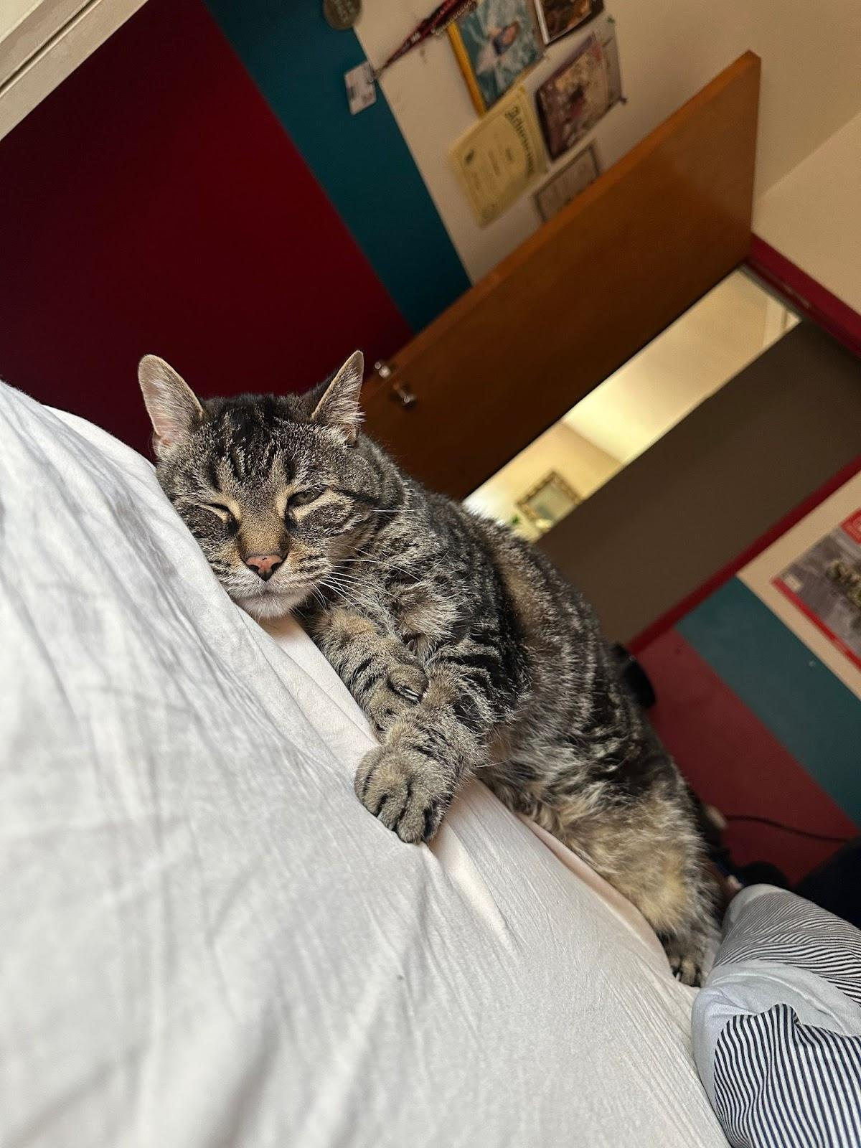
2. happy_sleep.jpg
3. Black and grey cat laying on bed, near asleep
4. Happy is an old cat. He spends a lot of his day lounging around, in whatever spot he feels is most comfortable at the time. He’s an indoor cat, but whenever we open the door to let the dogs out, he always comes running out so he can eat grass.
5. Happy is pretty friendly with one of my dogs, Katie. They don’t interact much, but when they do, it’s usually just friendly sniffs. My other dog, Izzy, however, loves biting at Happy. Happy usually will just run away, but sometime’s he’ll retalliate by giving Izzy a smack! It’s all in good fun though.
6. **Photo Gallery**
7. happy_izzy_water.jpg
8. Happy and black dog Izzy at their water bowl
9. happy_walk.jpg
10. Happy walking towards the camera
11. happy_bed.jpg
12. Happy laying in his cat bed
13. happy_closeup.jpg
14. A close-up photo of Happy’s face
15. **Likes**
16. Catnip
17. Pets
18. Sleeping
19. Lucas England

# Appa



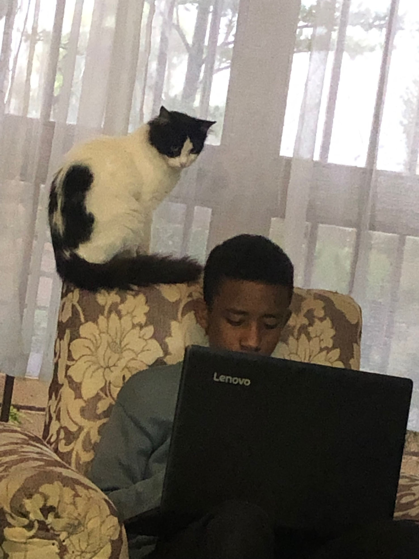

1. IMG_9104.jpeg
2. Appa learning how to code.
3. My cat Appa, is an Ethiopian cat. And like many Ethiopian cats she was allowed to leave the house and explore the neighborhood. Although she spent most of the time home, She would go out to explore and come back for food or dusk.
4. She was a very smart/ manipulative cat. Like many cats she didn’t like being touched unless she wanted it. She would avoid people she disliked but if she is hungry she will make you feel like she loves you even if you're her enemy.
5. **Photo Gallery – (Just write Photo Gallery)**
6. IMG_9106.png
7. Visual description of the image/movie
8. IMG_9107.png
9. Visual description of the image/movie
10. IMG_9105.jpeg
11. Visual description of the image/movie
12. file name
13. Visual description of the image/movie
14. Likes
15. chin rub
16. Running around
17. Eating meat and cake.
18. Abyesolome Assefa
19. Chunky Doll (Chonks)
20. 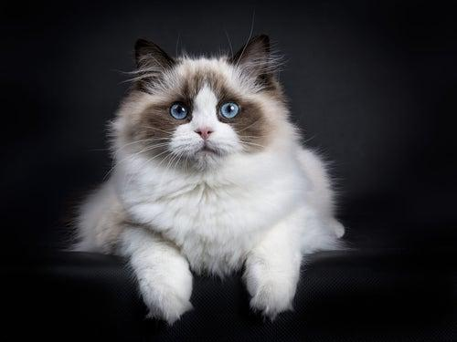
21. chonks.jpg
22. Furry white and dark brown ragdoll.
23. Chunky Doll or as he prefers to respond to, Chocks, is a 4-year-old ragdoll. His name was inspired by his breed and looks. As a kitten, he was even chunkier and blended right in with a fluffy white rug we had that he loved playing hide and seek in. He’s a very lazy but playful cat, only playful when he feels like it.
24. He’s a pretty but very difficult cat as he’s white but hates showers and loves rolling around in the house collecting dust. To get him into a bath we often have to lure him in with fake human treats. And even then he jumps right out of the bath and runs around the whole bathroom making the floors wet. Nevertheless, he’s a very soft, cuddly, and loving cat.

**Photo Gallery – (Just write Photo Gallery)**

1. chonks_happy.JPG
2. Younger Chonks being played with
3. chonks_baby.JPG
4. Baby Chonks on a cat bed
5. chonks_afterbath.JPG
6. Fluffy, grumpy Chonks after bath time
7. chonks_neutral.JPG
8. Chonks standing tall fully clean and white

**Likes – (Just write Likes)**

1. Human treats
2. Naps
3. Cuddles
4. Syeda Shahriah

## 1. Chief

1. Chief
2. 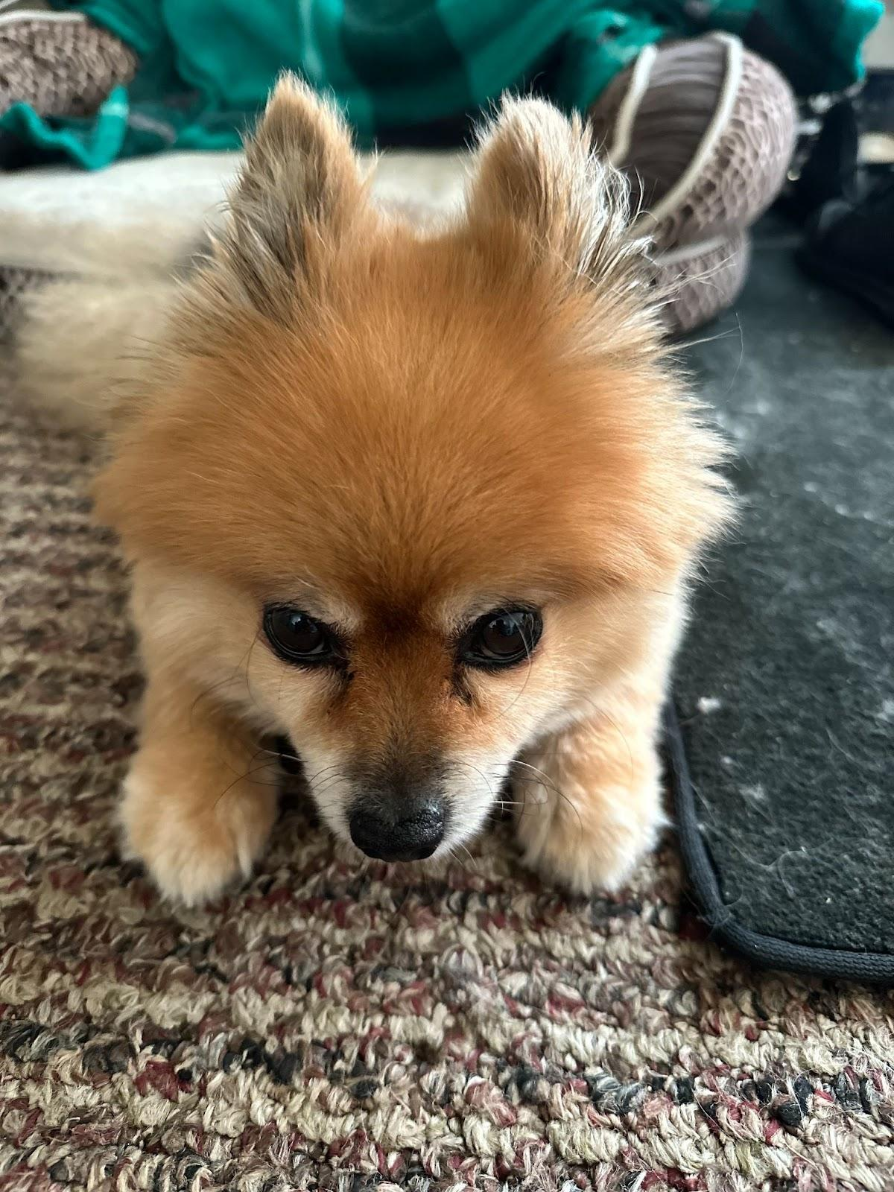
3. chief.jpeg
4. Pomeranian looking at camera with head bowed
5. Chief is a 9 year old pomeranian who loves to sleep as much as he can. He naps anywhere, ranging from someone's bed to the grass outside. He enjoys walking outside, but keep watch of him, otherwise he will try to consume geese poop.
6. He does not like any toys anymore as when he was younger, he watched a bigger toy shred his favorite one to pieces. He used to know how to roll over, but now replaced that memory with a spin as it is much easier.
7. **Photo Gallery**
8. chief_sleeping.jpg
9. Caramel pomeranian rolling in the grass
10. chief_cone.jpg
11. Caramel pomeranian with a cone around his head
12. chief_stare.jpg
13. Caramel pomeranian staring at geese
14. chief_licking.jpg
15. Caramel pomeranian licking a lid
16. **Likes**
17. Sleeping
18. Deli Chicken
19. Pets behind the ear
20. NaveenJohn Premkumar
21. Suki
22. .
23. suki_sleep.jpg
24. Suki curled up in a ball sleeping all cute.
25. Suki is an excellent cat! She is such a diva but I love her a lot.
26. She's pretty lazy and she always loves attention, and I always love giving her it.
27. **Photo Gallery**
28. suki_comfy.jpg
29. Suki sleeping all comfy, living the life.
30. suki_beanbag.jpg
31. Suki found a new favorite spot on the beanbag!
32. suki_weird.jpg
33. Suki sitting in a position that looks like she only has three arms and one leg! Silly cat.
34. suki_hide.jpg
35. Where did she go?? Suki hiding under my blanket… but her paws are sticking out.
36. **Likes**
37. Food
38. Attention
39. Hiding Under the blankets
40. Reyna Wood

# Mocha

1. Mocha
2. 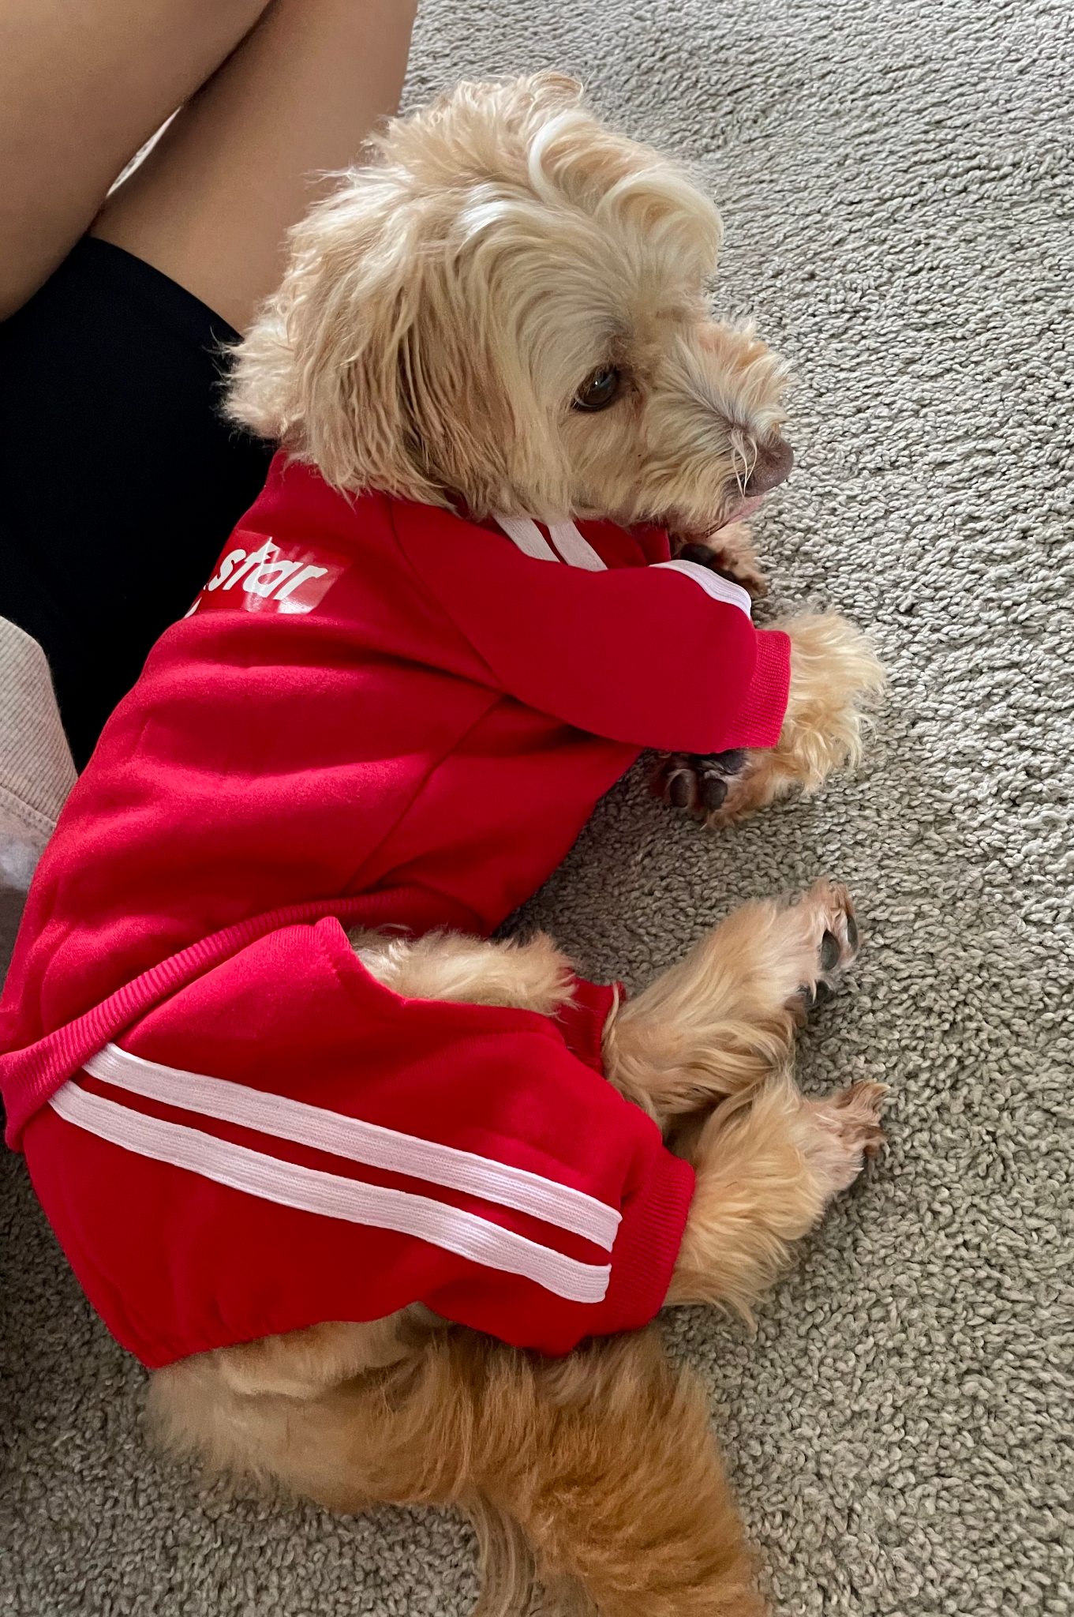
3. mocha.png
4. Mocha in spicy red training suit laying down
5. Mocha is a 5-year-old quarter Maltese, quarter Yorkshire Terrier, and half mutt. He was not adopted but actually born into the family and lives with his mommy Mochi and a loving family. Mocha likes to fool people into thinking that he's a dummy boy then making an intelligent comeback to surprise everyone of his big brain. He recently got a new toy that squeaks so high that he gets so excited everytime he chews on it.
6. If Mocha likes something or someone, he likes to rub his neck on it. This includes (but not limited to) rubber toys, favorite snacks, blankets, and human faces. As soon as someone lays down facing up, Mocha will run out from somewhere in the house and launch himself onto your face. It seems to be his favorite activity.
7. **Photo Gallery**
8. disney_mocha.png
9. Mocha giving disney character vibes
10. chunky_mocha.png
11. Mocha looking chunky from the back
12. whirlwind_mocha.png
13. Mocha caught mid shake
14. sleazy_mocha.png
15. Mocha looking a little bit high
16. **Likes**
17. Rubber toys
18. Walks
19. Anything edible
20. Jeongin Bae
21. Cooper
22. 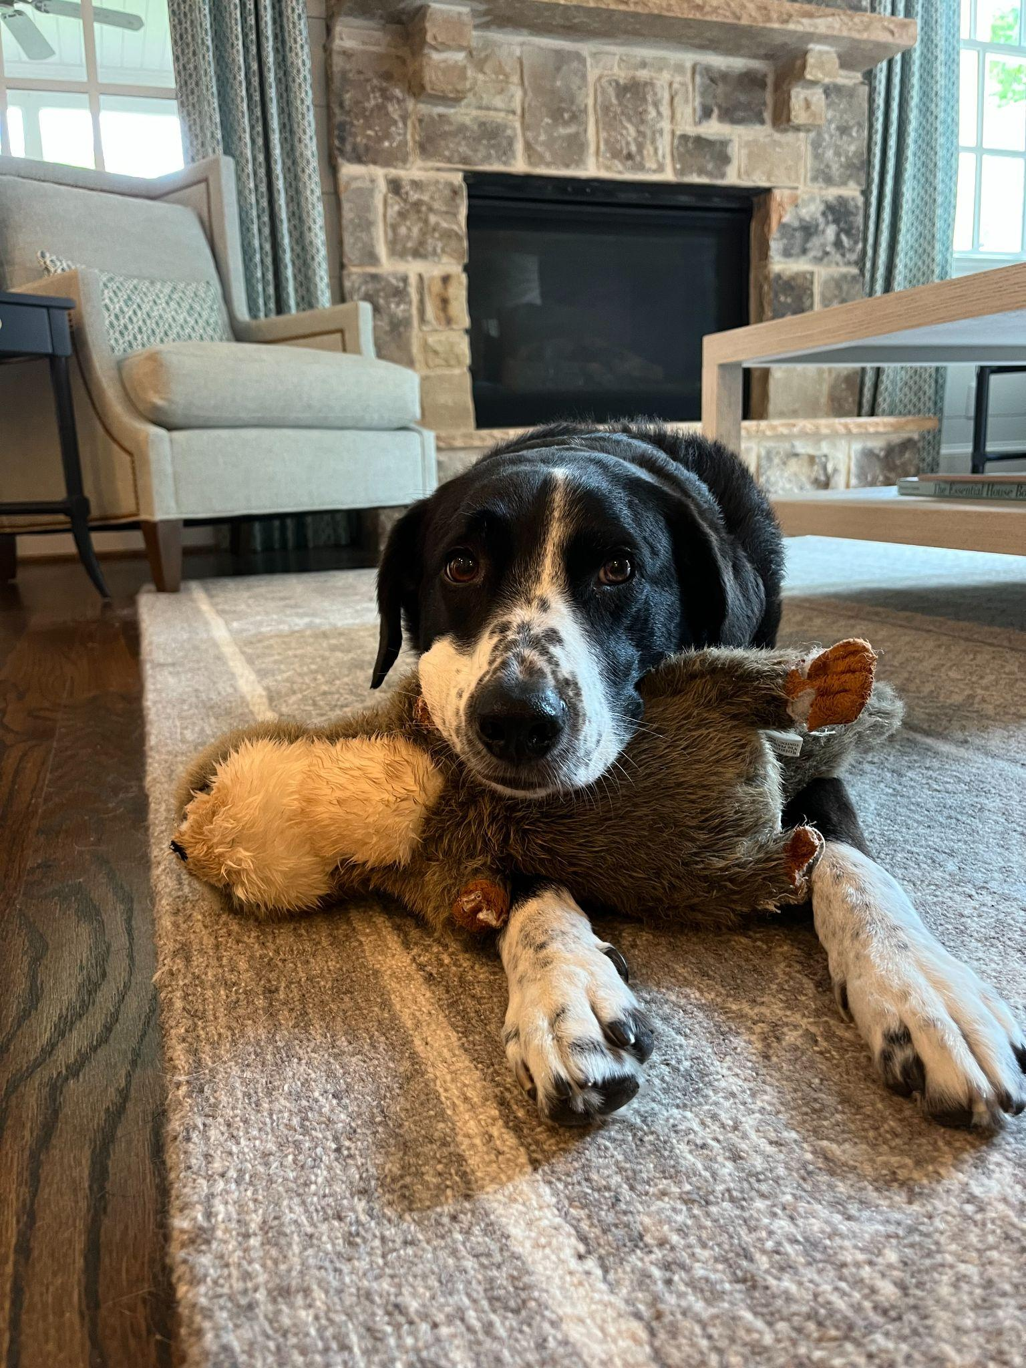
23. cooper.jpeg
24. Border collie and lab mix laying his head on his stuffed animal toy
25. Cooper is an 8yr old border collie and lab mix. We rescued him from the Humane Society as a puppy! He loves going on long walks/runs, but he stops to sniff something every few steps. He’s pretty friendly, but he loves to loudly bark at delivery people who ring the doorbell.
26. Whenever it’s movie night, Cooper has to join on the couch/bed or he feels left out. He loves to cuddle and pats on his tummy. Cooper will play fetch for about 2 or 3 rounds, but he quickly gets bored. He leaves his toys all around the house for the rest of the family to find.
27. **Photo Gallery – (Just write Photo Gallery)**
28. cooper_closeup.JPG
29. Border collie / lab mix putting his face close to the camera
30. cooper_smiling.JPG
31. Black and white colored dog smiling directly at the camera
32. cooper_flowers.jpeg
33. Border collie / lab mix sniffing a bouquet of flowers in the sun
34. cooper_puppy.JPG
35. Small border collie / lab mix puppy laying on the carpet
36. **Likes – (Just write Likes)**
37. Peanut butter
38. Going on long walks
39. Sleeping
40. Chloe Emch